


Annual report of activities 2024-25

nopta.gov.au
Acknowledgement of Country
Our department recognises the First Peoples of this Nation and their ongoing cultural and spiritual connections to the lands, waters, seas, skies, and communities.
We Acknowledge First Nations Peoples as the Traditional Custodians and Lore Keepers of the oldest living culture and pay respects to their Elders past and present. We extend that respect to all First Nations Peoples.
-------------------------------------------------------------------------------------------------------------
@Commonwealth of Australia 2025 Ownership of intellectual property rights
Unless otherwise noted, copyright (and any other intellectual property rights, if any) in this publication is owned by the Commonwealth of Australia.
Creative Commons License Creative Commons Attribution 4.0 International Licence CC BY 4.0
All material in this publication is licensed under a Creative Commons Attribution 4.0 International Licence, with the exception of:
- the Commonwealth Coat of Arms
- content supplied by third parties
- logos
- any material protected by trademark or otherwise noted in this publication.
Creative Commons Attribution 4.0 International Licence is a standard form licence agreement that allows you to copy, distribute, transmit and adapt this publication provided you attribute the work. A summary of the licence terms is available from https://creativecommons.org/licenses/by/4.0/. The full licence terms are available from https://creativecommons.org/licenses/by/4.0/legalcode.
This notice excludes the Commonwealth Coat of Arms, any logos and any material protected by trademark or otherwise noted in the publication, from the application of the Creative Commons licence. These are all forms of property which the Commonwealth cannot or usually would not licence others to use.
ISSN: 2205-8230 (print version) | ISSN 2205-8249 (online)
If you are having difficulty accessing content in this document with accessibility tools, please contact us.
For more information about this report please contact:
Business Manager, National Offshore Petroleum Titles Administrator, Department of
Industry, Science and Resources
GPO Box 7871, Perth WA 6850
Phone: (08) 6424 5300 Email: cap@nopta.gov.au

Contents
Annual report of activities 2024-25 1
Welcome 5
About us 6
Established 6
Industries administered 6
Values 6
Purpose 6
Functions 7
Principles of regulator best practice 7
Organisational structure 8
Our people 12
Performance highlights 12
Activity highlights 12
2024-25 Industry activity overview 13
Activity and insights 14
OEI Iicence activity insights 14
Gippsland declared area update 15
OEI milestones 17
Petroleum titles activity insights 18
Applications submitted 20
Petroleum development – committed to and in progress 24
Petroleum exploration 26
Petroleum development milestones 27
Production – offshore basins 28
Production offshore basins - continued 30
GHG storage activity 32
GHG storage activity insights 33
Declaration of an identified storage formation 34
Governance and strategy 35
Governance 35
Pillar 1: Resource stewardship 36
Pillar 2: Leveraging information and technology 40
Pillar 3: Engagement 41
Pillar 4: Regulatory excellence 43
Performance outcomes 46
2024-25 performance 46
Application process overview 53
Who does what in government? 55
Whole of government overview 55
Financials 58
OPGGS Act – Cost recovery overview 58
Fees 59
OPGGS Act - cost effectiveness and financial results 60
OEI Act – cost recovery overview 61
OEI Act - cost effectiveness and financial results 62

Welcome
This is the 2024-25 Annual report of activities for the financial year ending 30 June 2025.
This report outlines the achievements and performance of the National Offshore Petroleum Titles Administrator (NOPTA or Titles Administrator) and the Offshore Infrastructure Registrar (the Registrar). These dual statutory roles are administered by the NOPTA branch within the Department of Industry, Science and Resources, and are integral to supporting a strong offshore resources sector.
This report provides a detailed account of our activities and financials, and reaffirms our commitment to sound governance, continuous improvement, and the stewardship of Australia’s offshore energy resources.
Australia’s offshore energy landscape continues to evolve. In 2024-25, we saw a continued progress in the emerging offshore electricity and greenhouse gas (GHG) sectors. Thirteen feasibility licences have been granted across four declared zones, with ten currently active near major demand centres. These licences represent a combined potential generation capacity of 25 gigawatts.
Ten greenhouse gas assessment permits were issued to support exploration of geological formations suitable for carbon sequestration, contributing to national efforts to reduce emissions at scale.
The offshore petroleum sector has also continued to consolidate, with titleholders rationalising portfolios, securing long-term access to infrastructure, and exploring opportunities to extend asset life. Two petroleum production licences were granted in the Otway basin, supporting domestic gas supply for the East coast market.
Despite the challenges of recent years, the branch has consistently delivered against its performance targets. In 2024-25, we met our published timeframes 99% of the time – our highest achievement to date.
The branch is committed to ensuring offshore energy resources are managed responsibly and work for the benefit of all Australians. We thank our stakeholders for their continued support, engagement and collaboration.

About us

Established
On 1 January 2012, the General Manager of the branch was appointed the Titles Administrator under the Offshore Petroleum and Greenhouse Gas Storage Act 2006 (OPGGS Act) by the Secretary of the Department of Industry, Science, and Resources (DISR). The Titles Administrator is assisted by staff within the NOPTA branch.
On 16 December 2022, the General Manager of the NOPTA branch was appointed as the Registrar under the Offshore Electricity Infrastructure Act 2021 (OEI Act) by the Secretary of the Department of Climate Change, Energy, the Environment and Water (DCCEEW). The Registrar is assisted by staff within the NOPTA branch.

Industries administered
- Petroleum
- Greenhouse gas storage
- Offshore electricity.

Values
- We are: innovative, enthusiastic and endeavour to improve the way we work and are flexible, responsive and embrace change.
- Our people: act with honesty and integrity and are inclusive and respect the views of others.
- APS values are: Impartial, committed to service, accountable, respectful, ethical and stewardship.

Purpose
To advise government and decision makers on the grant and administration of titles and licences, monitor compliance with title and licence conditions, data management and resource stewardship.

Functions
- Provide information, assessments, analysis, reports, advice and recommendations to the relevant decision makers under the OPGGS Act and OEI Act.
- Facilitate life of title / licence administration, including compliance monitoring.
- Engage with titleholders / licence holders on their performance in meeting regulatory obligations and expectations.
- Manage the submission and release of data.
- Act as decision maker for the approval and registration of a change in control of a company.
- Act as decision maker for transfers and dealings, and for granting of short-term petroleum titles and greenhouse gas titles.
- Maintain the public registers of offshore petroleum titles, greenhouse gas titles and offshore electricity licences.
- Cooperate with the National Offshore Petroleum Safety and Environmental Management Authority (NOPSEMA) and the Offshore Infrastructure Regulator (OIR) on matters relating to the administration and enforcement of the OPGGS Act, OEI Act and associated regulations.

Principles of regulator best practice
- Continuous improvement and building trust.
- Risk based and data driven.
- Collaboration and engagement.

Organisational structure

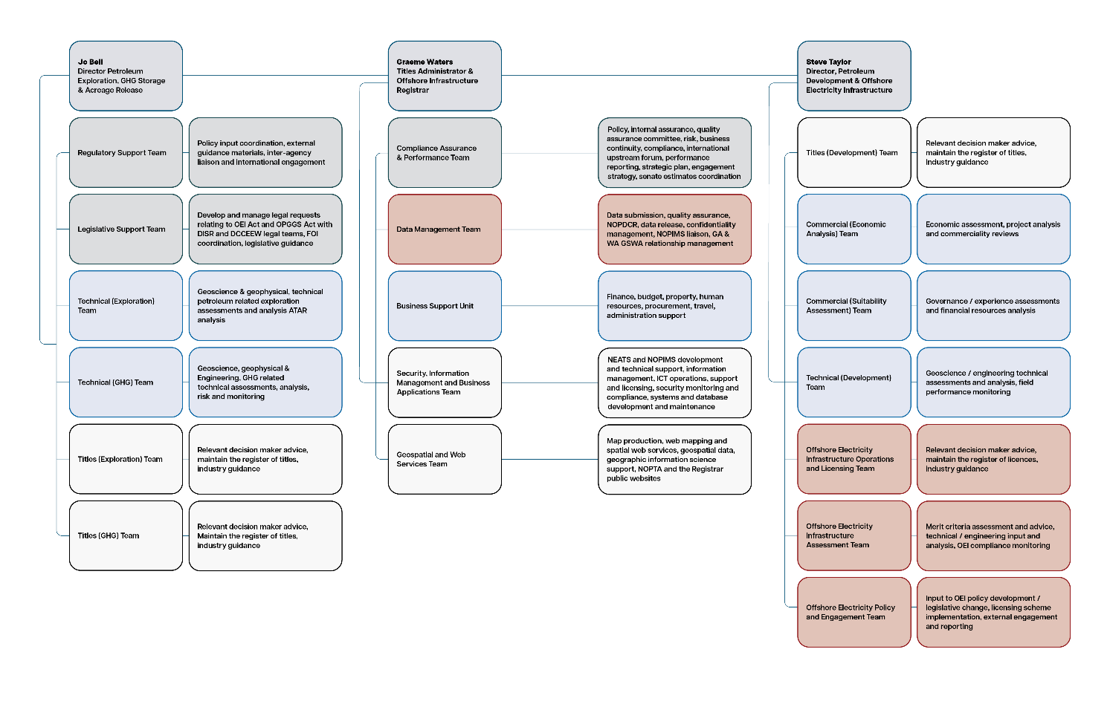
Figure 1: Organisational structure for NOPTA and the Registrar

Organisational structure – full alternative text, figure 1

Level 1: General Manager
Graeme Waters, Titles Administrator and Offshore Infrastructure Registrar

Level 2: Business unit managers
Table 1: List of business units reporting to the General Manager
Business unit | Functions
Compliance, assurance and performance team | Policy, internal assurance, quality assurance committee, risk, business continuity, compliance, international upstream forum, performance reporting, strategic plan, engagement strategy, senate estimates coordination.
Data management team | Data submission, quality assurance, NOPDCR, data release, confidentiality management, NOPIMS liaison, Geoscience Australia & Geological Survey of Western Australia relationship management.
Business support team | Finance, budget, property, human resources, procurement, travel, administrative support.
Security, information management and business application team | The National Electronic Approvals Tracking System’s (NEATS) and National Offshore Petroleum Information Management System’s development and technical support, information management, ICT operations, support and licensing, security monitoring and compliance, systems and database development and maintenance.

Level 2: Director, Jo Bell
Jo Bell, Petroleum exploration, greenhouse gas storage and acreage release
Table 2: List of business units reporting to Director Jo Bell
Business unit | Functions
Regulatory support team | Policy input coordination, external guidance materials, inter-agency liaison and international engagement.
Legislative support team | Develop and manage legal requests relating to OEI Act and OPGGS Act with DISR and DCCEEW legal teams, FOI coordination, legislative guidance.
Technical (exploration) team | Geoscience and geophysical, technical petroleum related exploration assessments and analysis, ATAR analysis.
Technical (GHG) team | Geoscience, geophysical and engineering, GHG related technical assessments, analysis, risk and monitoring.
Titles (exploration) team | Relevant decision maker advice, maintain the register of titles, industry guidance.
Titles (GHG) team | Relevant decision maker advice, maintain the register of titles, industry guidance.

Level 2: Director, Steve Taylor
Steve Taylor, Petroleum development and offshore electricity infrastructure
Table 3: List of business units reporting to the Director Steve Taylor
Business unit | Functions
Titles (development) team | Relevant decision maker advice, maintain the register of titles, industry guidance.
Commercial (economic analysis) team | Economic assessment, project analysis and commerciality reviews.
Commercial (suitability assessment) team | Governance / experience assessments and financial resources analysis.
Technical (development) team | Geoscience / engineering technical assessments and analysis, field performance monitoring.
Offshore electricity infrastructure operations and licensing team | Relevant decision maker advice, maintain the register of licences, industry guidance.
Offshore electricity infrastructure assessment team | Merit criteria assessment and advice, technical / engineering input and analysis, OEI compliance monitoring.
Offshore electricity policy and engagement team | Input to OEI policy development / legislative change, licensing scheme implementation, external engagement and reporting.

Our people
As of 30 June 2025, the branch had 136 total staff and contractors. Our workforce is based across our Perth and Melbourne offices, with remote workers in Queensland, New South Wales, the Australian Capital Territory, Victoria and South Australia.
During 2024-25, the branch recruited personnel for our Offshore Electricity Infrastructure team to bolster our skills, capability and capacity, along with additional staff in the geoscience, engineering and legislative and regulatory support areas.
As at 30 June 2025 – the branch has:
- More than 1000 total combined years in the Australian Public Service
- 554 total combined years at NOPTA
- 136 total staff and contractor headcount
- 300+ total combined industry years’ experience
- 86% staff and 14% contractors
- 87% full-time staff and 13% part-time staff
- 60% females to 40% males workforce gender balance (including contractors).

Performance highlights
During the 2024-25 year, the branch:
- 99% met target application assessment timeframes (petroleum and GHG applications)
- 270 petroleum applications submitted
- 21 GHG applications submitted
- 12 OEI feasibility licence applications submitted
- 624TB of data authorised for public release
- 900+ meetings held with stakeholders, across petroleum, GHG and OEI sectors.

Activity highlights
In offshore petroleum:
- 5 petroleum exploration permits were renewed
- 4 production licences under assessment
- 2 production licences were granted.
In offshore GHG:
- 10 new GHG assessment permits were granted
- 2 Declaration of Identified Storage Formation are currently under assessment.
In offshore electricity:
- 6 feasibility licences were granted in the Gippsland declared area
- 1 feasibility licences was granted for the Southern Ocean declared area.

2024-25 Industry activity overview
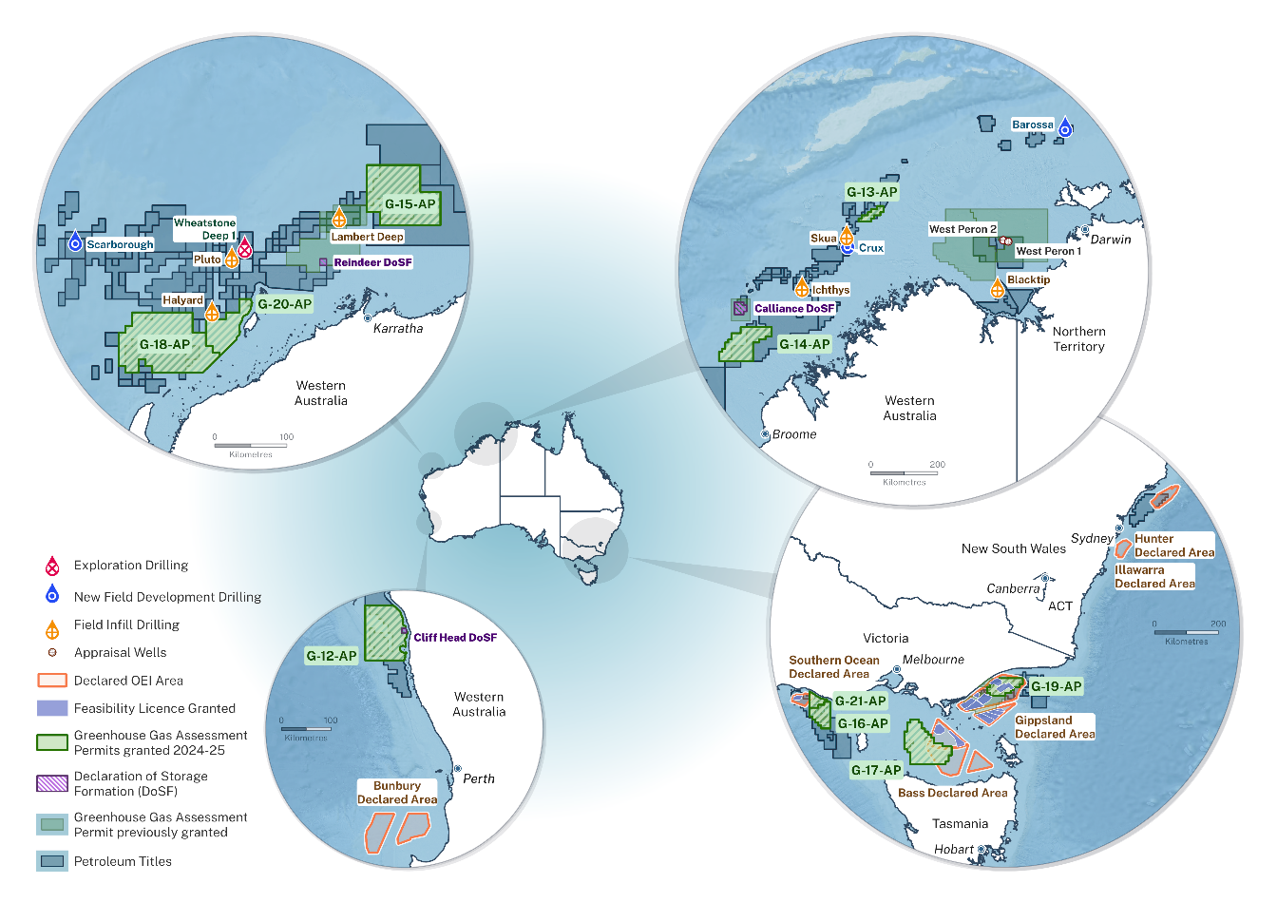
Figure 2: A national map showing offshore energy activity and licensing highlights in Commonwealth waters for the 2024-25 financial year.

2024-25 Industry activity overview map – full alternative text, figure 2
The national map in Figure 2 includes 4 circular inset maps focusing on regional activity hubs in offshore Western Australia, the Northern Territory , New South Wales and Victoria.
These insets magnify project footprints and show areas where multiple energy activities occur. In the North-west, petroleum and greenhouse gas projects overlap, while in the South-east, petroleum, greenhouse gas, and offshore electricity activities coexist.
A legend outlines the symbols and colour coding used to distinguish the well types and licensing categories. The main information on the map includes:
- declared OEI areas
- exploration drilling locations
- new field development drilling locations
- feasibility licence granted
- field infill drilling locations
- appraisal well locations
- declaration of storage formation (DoSF) areas
- greenhouse gas assessment permits granted 2024-25.
Background information shown on the map:
- greenhouse gas assessment permits previously granted
- petroleum titles.

Activity and insights

OEI Iicence activity insights
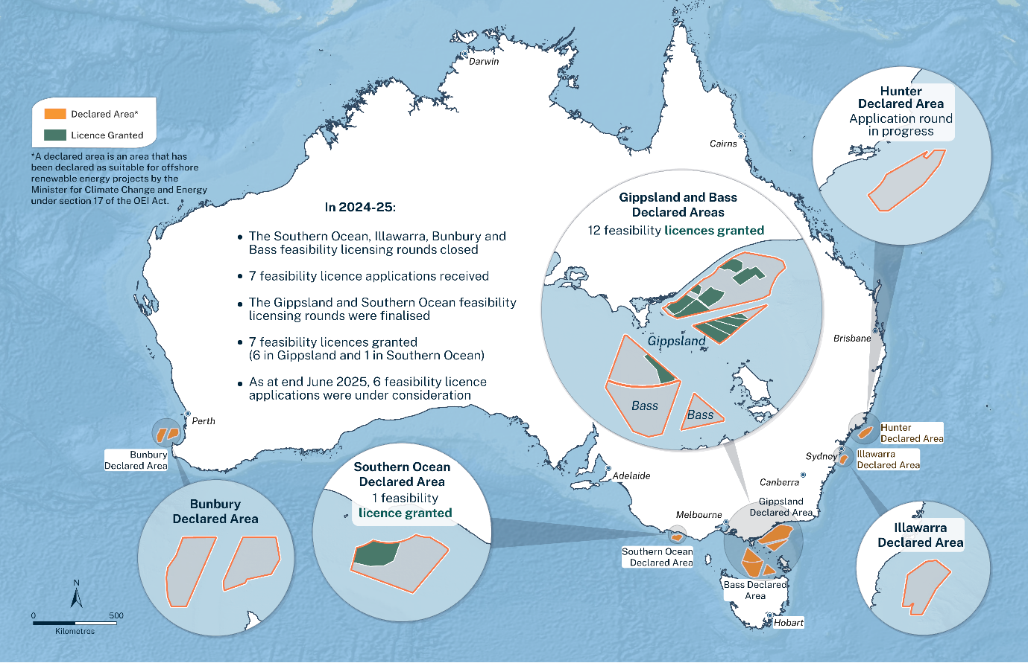
Figure 3: Map of offshore electricity declared areas and feasibility licences in Commonwealth waters

OEI licence activity insights – full alternative text, figure 3
A national map showing offshore electricity declared areas and feasibility licences in Commonwealth jurisdiction. Declared areas are outlined and labelled, indicating zones suitable for electricity infrastructure development. Within these areas, feasibility licences are marked, showing locations where applications have been granted.
There are 5 inset maps showing these declared areas and feasibility licences:
- Bunbury declared area, in Western Australian waters, with no feasibility licences.
- Southern ocean declared area, in Victorian waters, with one feasibility licence granted.
- Gippsland declared area, in Victorian waters, with 12 feasibility licences granted, and Bass declared area, in Tasmanian waters, with no feasibility licences.
- Hunter declared area, in New South Wales waters, with one feasibility licence offered.
- Illawarra declared area, in New South Wales waters, with no feasibility licences.
Text on the map states ‘In 2024-25:
- the Southern ocean, Illawarra, Bunbury and Bass feasibility licensing rounds closed
- 7 feasibility licence applications received
- the Gippsland and Southern ocean feasibility licensing rounds were finalised
- 7 feasibility licences granted (6 in Gippsland and 1 in Southern ocean).’
As at the end of June 2025, 6 feasibility licence applications were under consideration.
Below the map’s legend, it states: ‘a declared area is an area that has been declared as suitable for offshore renewable energy projects by the Minister for Climate Change and Energy under section 17 of the OEI Act.’

Gippsland declared area update
The Minister for Climate Change and Energy granted 12 feasibility licences by the end of June 2025, after a highly competitive first feasibility licensing round in Gippsland, Victoria.
The offshore wind projects proposed under these licences have a potential energy generation of up to 25 gigawatts.
This is more than the current total installed generation capacity in Victoria via conventional generation and renewables, highlighting the future potential of offshore wind in Australia.
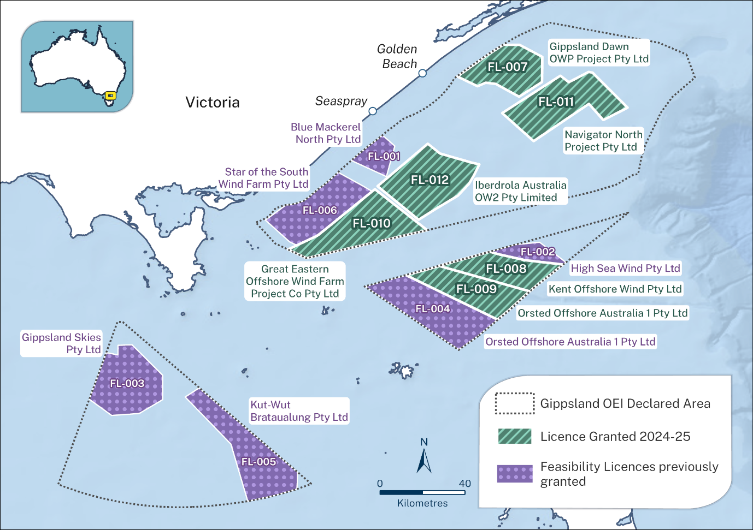
Figure 4: A regional map showing offshore electricity feasibility licences of the Gippsland basin

Victorian map showing electricity feasibility licences – full alternative text,figure 4
A regional map showing declared areas in the Gippsland basin in Victoria, under the Offshore Electricity Infrastructure Act 2021. Dotted-line polygons outline declared areas. Within these, striped shaded areas indicates feasibility licences granted during the 2024–25 financial year, while dotted shading shows licences granted in previous years. A legend explains the colour coding and spatial boundaries of declared areas and licences.
There are 6 feasibility licences that have been granted in the 2024-25 reporting period:
- FL-007 Gippsland Dawn OWP Project Pty Ltd
- FL-008 Kent Offshore Wind Pty Ltd
- FL-009 Orsted Offshore Australia 1 Pty Ltd
- FL-010 Great Eastern Offshore Wind Farm Project Co Pty Ltd
- FL-011 Navigator North Project Pty Ltd
- FL-012 Iberdrola Australia OW2 Pty Limited.
There are 6 feasibility licences granted in previous reporting periods:
- FL-001 Blue Mackerel North Pty Ltd
- FL-002 High Sea Wind Pty Ltd
- FL-003 Gippsland Skies Pty Ltd
- FL-004 Orsted Offshore Australia 1 Pty Ltd
- FL-005 Kut-Wut Brataualung Pty Ltd
- FL-006 Star of the South Wind Farm Pty Ltd.

OEI milestones

June/July 2024
- Registrar published forms relating to Change-In-Control (CIC) and transfer of licences.
- Registrar received and initiated assessment of 1 application (Southern ocean).
- 7 feasibility licences granted (Gippsland).
- Attended first Gippsland licence holders advisory committee (GLAC) meeting.
- First joint conference booth with DCCEEW and regulator (AuWE).

August 2024
- Registrar received and initiated assessment of 1 feasibility licence application (Illawarra).
- ACCC final determination for overlapping group process.

November/December 2024
- Overlapping applications regulations passed.

January 2025
- Registrar received and initiated assessment of 4 feasibility licences applications (Bunbury).

February 2025
- TIL guidance published.
- Electricity infrastructure legislation amendment Bill 2025 passed.

March/April 2025
- feasibility licence granted (Southern ocean).
- annual licence report guidance published.
- Registrar received and initiated assessment of 1 feasibility licence application (Bass).

May/June 2025
- First CIC application received and approved.
- Registrar starts review of first 5 feasibility licence annual reports.
- overlapping application group process (Bunbury).

Petroleum titles activity insights
In 2024-25, there were 328 active petroleum titles in offshore Commonwealth waters (Figure 2).
During this period, 8 new titles were granted, including 5 exploration permits, one retention lease, and 2 production licences.
One location was declared over the Bratwurst Flank-Libra fields in the offshore area of Ashmore and Cartier islands.
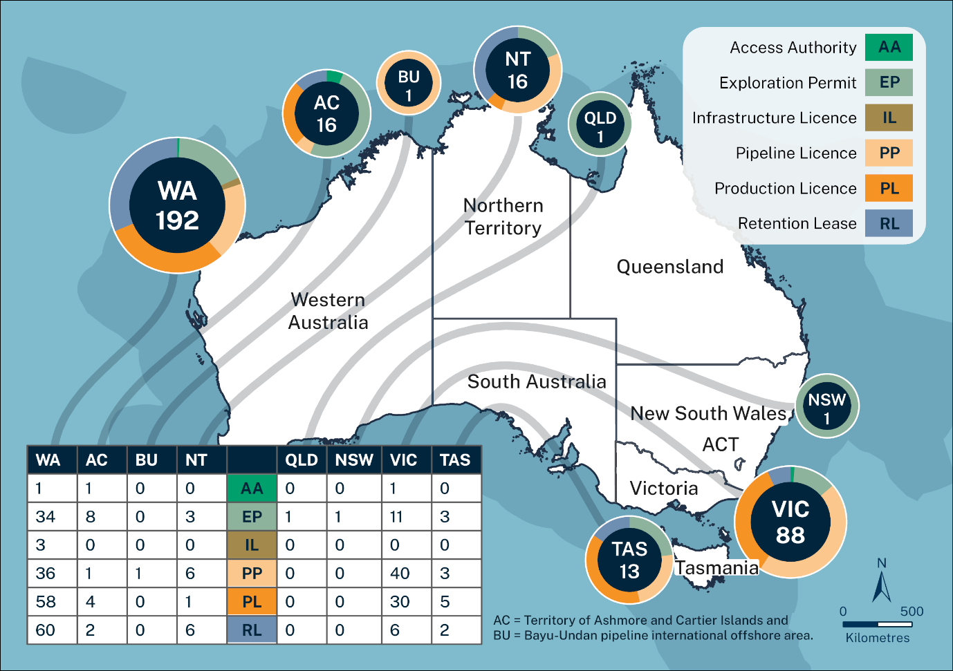
Figure 5: total number of offshore petroleum titles by offshore areas, at 30 June 2025

Total offshore petroleum titles - full alternative text, figure 5
Table 4: Total number of offshore petroleum titles by offshore areas, at 30 June 2025
 | WA | AC*** | BU | NT | QLD | NSW | VIC | TAS | Total
Access authority (AA) | 1 | 1 | 0 | 0 | 0 | 0 | 1 | 0 | 3
Exploration permit (EP) | 34 | 8 | 0 | 3 | 1 | 1 | 11 | 3 | 61
Infrastructure licence (IL) | 3 | 0 | 0 | 0 | 0 | 0 | 0 | 0 | 3
Pipeline licence (PP) | 36 | 1 | 1 | 6 | 0 | 0 | 40 | 3 | 87
Production licence (PL) | 58 | 4 | 0 | 1 | 0 | 0 | 30 | 5 | 98
Retention lease (RL) | 60 | 2 | 0 | 6 | 0 | 0 | 6 | 2 | 76
Total | 192 | 16 | 1 | 16 | 1 | 1 | 88 | 13 | 328
***AC= Territory of Ashmore and Cartier Islands
BU= Bayu-Undan pipeline international offshore area.

Applications submitted
During the 2024-25 period, 270 applications were submitted.
Table 5: Applications submitted in 2024-25
Decision maker | WA | SA | NT | VIC | AC*** | NSW | QLD | TAS | BU** | Total
Joint Authority | 31 | 0 | 8 | 18 | 7 | 1 | 0 | 2 | 0 | 67
Titles Administrator | 139 | 0 | 11 | 41 | 5 | 0 | 0 | 7 | 0 | 203
Total | 170 | 0 | 19 | 59 | 12 | 1 | 0 | 9 | 0 | 270
The following charts (figures 6 and figure 7) show a detailed breakdown by month of application types received. Refer to the footnotes below.

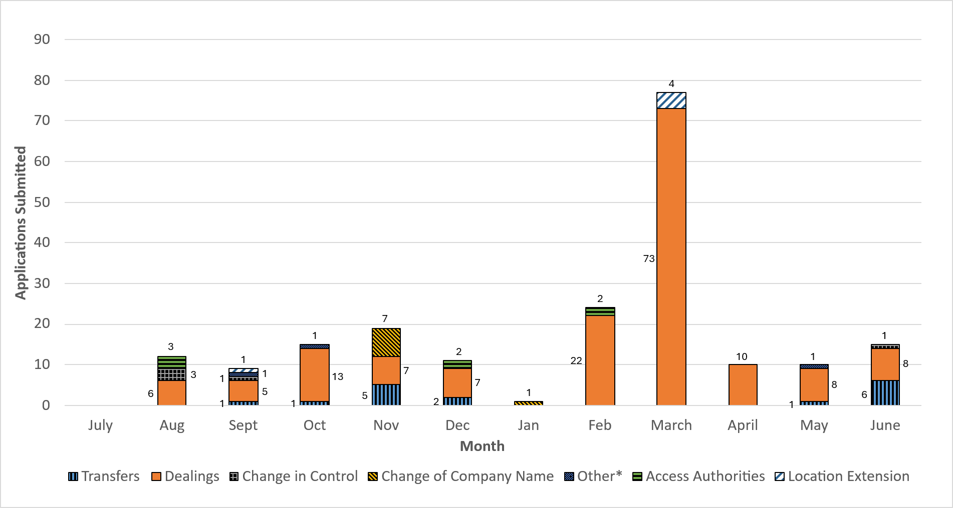
Figure 6: Titles Administrator applications submitted in 2024-25

Titles administrator applications submitted by month in 2024 –25 –full alternative text, figure 6
Table 6: Titles Administrator applications submitted by month in 2024-25
Month/  applications submitted | Transfers | Dealings | Change  in control | Change of company name | Other* | Access authorities | Location extension |  | Total
July | 0 | 0 | 0 | 0 | 0 | 0 | 0 | 0
August | 0 | 6 | 3 | 0 | 0 | 3 | 0 | 12
September | 1 | 5 | 1 | 0 | 1 | 0 | 1 | 9
October | 1 | 13 | 0 | 0 | 1 | 0 | 0 | 15
November | 5 | 7 | 0 | 7 | 0 | 0 | 0 | 19
December | 2 | 7 | 0 | 0 | 0 | 2 | 0 | 11
January | 0 | 0 | 0 | 1 | 0 | 0 | 0 | 1
February | 0 | 22 | 0 | 0 | 0 | 2 | 0 | 24
March | 0 | 73 | 0 | 0 | 0 | 0 | 4 | 77
April | 0 | 10 | 0 | 0 | 0 | 0 | 0 | 10
May | 1 | 8 | 0 | 0 | 1 | 0 | 0 | 10
June | 6 | 8 | 1 | 0 | 0 | 0 | 0 | 15

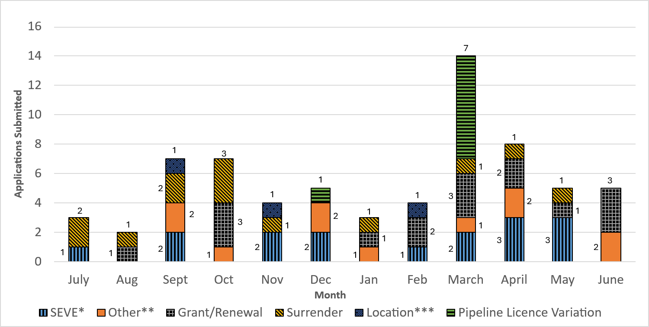
Figure 7: Joint Authority applications submitted in 2024-25
Details on the application types and asterisks used in this chart are in the footnotes

Joint Authority applications submitted in 2024-25 –full alternative text, figure 7
Table 7: Joint Authority applications submitted by month in 2024-25
Month/  Applications submitted | SEVE* | Other** | Grant/  Renewal | Surrender | Location*** | Pipeline Licence Variation | Total
Jul | 1 | 0 | 0 | 2 | 0 | 0 | 3
Aug | 0 | 0 | 1 | 1 | 0 | 0 | 2
Sept | 2 | 2 | 0 | 2 | 1 | 0 | 7
Oct | 0 | 1 | 3 | 3 | 0 | 0 | 7
Nov | 2 | 0 | 0 | 1 | 1 | 0 | 4
Dec | 2 | 2 | 0 | 0 | 0 | 1 | 5
Jan | 0 | 1 | 1 | 1 | 0 | 0 | 3
Feb | 1 | 0 | 2 | 0 | 1 | 0 | 4
Mar | 2 | 1 | 3 | 1 | 0 | 7 | 14
Apr | 3 | 2 | 2 | 1 | 0 | 0 | 8
May | 3 | 0 | 1 | 1 | 0 | 0 | 5
Jun | 0 | 2 | 3 | 0 | 0 | 0 | 5
Total | 16 | 11 | 16 | 13 | 3 | 8 | 67

Figure 8 below shows total application submissions annually over the last 5 reporting periods. Refer to footnotes.
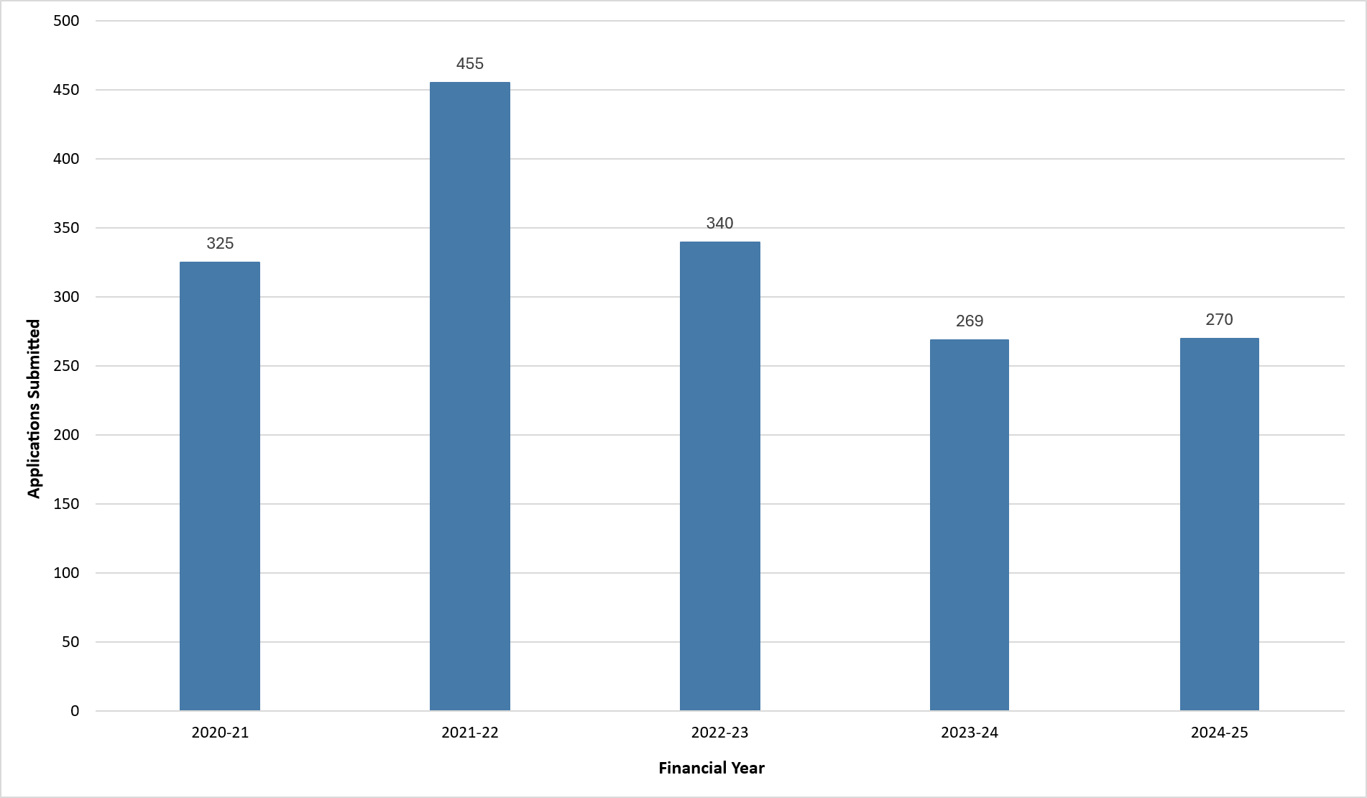
Figure 8: Total petroleum applications submitted from 2020-21 to 2024-25

Petroleum applications submitted from 2020-21 to 2024-25 - full alternative text, figure 8
Figure 8 shows the total number of petroleum applications submitted by year:
  - 2020-21: 325
  - 2021-22: 455
  - 2022-23: 340
  - 2023-24: 269
  - 2024-25: 270.

Petroleum development – committed to and in progress
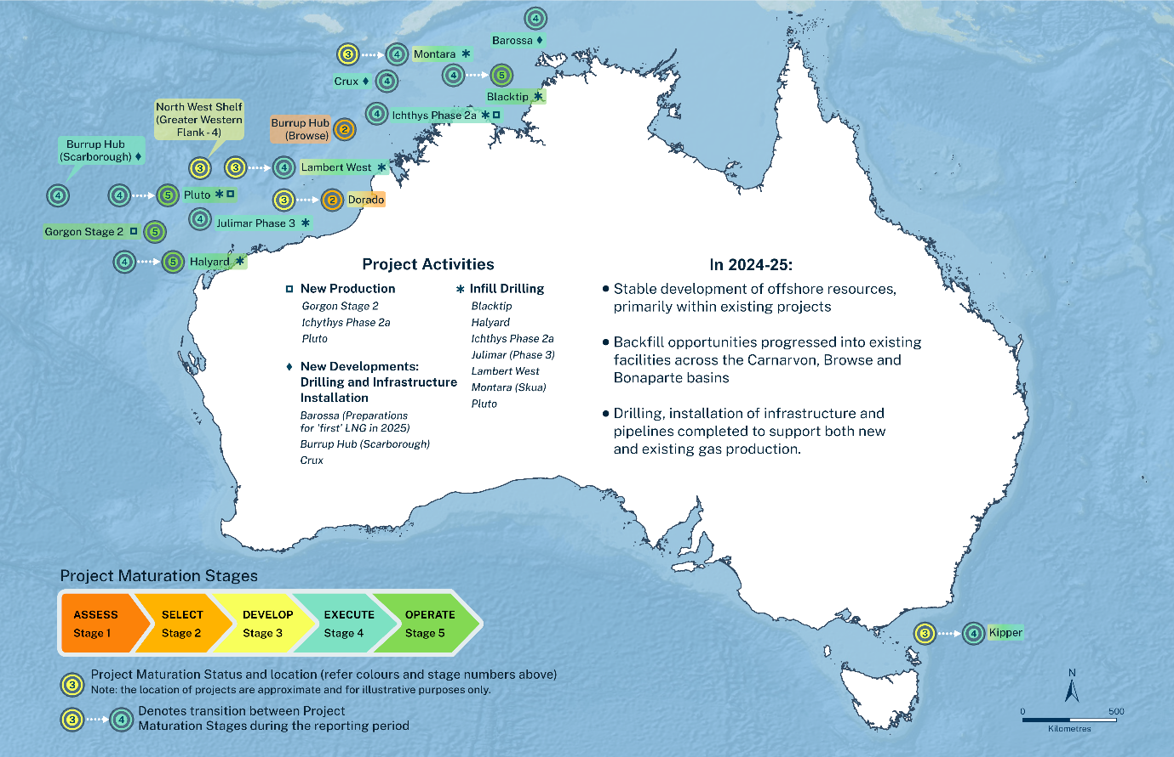
Figure 9: A national map showing offshore petroleum project development maturity across five stages
National map showing offshore petroleum project development - full alternative textfigure 9
A national map showing offshore petroleum project development maturity across Commonwealth waters, based on a five-stage, start-up cycle. Each project location is labelled with its corresponding development stage, indicating progress from early planning to production readiness. During 2024–25, the petroleum industry focused development efforts within producing basins, aiming to optimise existing infrastructure and accelerate project maturation.
Colours represent project maturation stages for each project:
- Stage 1 assess
- Stage 2 select
- Stage 3 develop
- Stage 4 execute
- Stage 5 operate.
Arrows denote transition between project maturation stages in the reporting period.
Symbols represent project activities for each project:
- new production
- infill drilling
- new developments: drilling and infrastructure installation.
Projects, stages, and activities in Western Australian waters:
  - Barossa, stage 4 (execute), new developments: drilling and infrastructure installation activities (preparations for 'first' LNG in 2025)
  - Blacktip, transitioned from stage 4 to stage 5 (operate), infill drilling activities
  - Burrup Hub (Browse), stage 2 (select), no change to project activities
  - Burrup Hub (Scarborough), stage 4 (execute), new developments: drilling and infrastructure installation activities
  - Crux, stage 4 (execute), new developments: drilling and infrastructure installation activities
  - Dorado, transitioned from stage 3 to stage 2 (select), reviewing project activities
  - Gorgon stage 2 (select), stage 5 (operate), new production activities
  - Halyard, transitioned from stage 4 to stage 5 (operate), infill drilling activities
  - Ichthys phase 2a, stage 4 (execute), infill drilling and new production activities
  - Julimar phase 3, stage 4 (execute), infill drilling
  - Lambert West, transitioned from stage 3 to stage 4 (execute), infill drilling activities
  - Montara, transitioned from stage 3 to stage 4 (execute), infill drilling activities
  - North West Shelf (Greater Western Flank - 4), stage 3 (develop), development activities only
  - Pluto, transitioned from stage 4 to stage 5 (operate), infill drilling and new production activities.
Projects, stages, and activities in Victorian waters:
  - Kipper, transitioned from stage 3 to stage 4 (execute), executing project activities.
Text on the map states, ‘In 2024-25:
  - stable development of offshore resources, primarily within existing projects
  - backfill opportunities progressed into existing facilities across the Carnarvon, Browse and Bonaparte basins
  - drilling, installation of infrastructure and pipelines completed to support both new and existing gas production.’

Petroleum exploration
The OPGGS Act establishes Australia’s legislative framework for offshore petroleum activities, defining the rights, responsibilities and entitlements of governments and industry. The framework governs the full lifecycle of operations, from exploration through to production and decommissioning.
In 2024-25:
- 5 new petroleum exploration permits renewed
- 1 exploration well was drilled in a production licence in the Northern Carnarvon basin
- 1 location was declared over the Bratwurst Flank-Libra gas fields following drilling of the Bratwurst-1 well in 2019
- 4 geophysical/geotechnical surveys were conducted to assess rig location sites. Three were in the Otway basin, and one in the Petrel sub basin. The Titles Administrator granted 7 petroleum access authorities related to these activities.
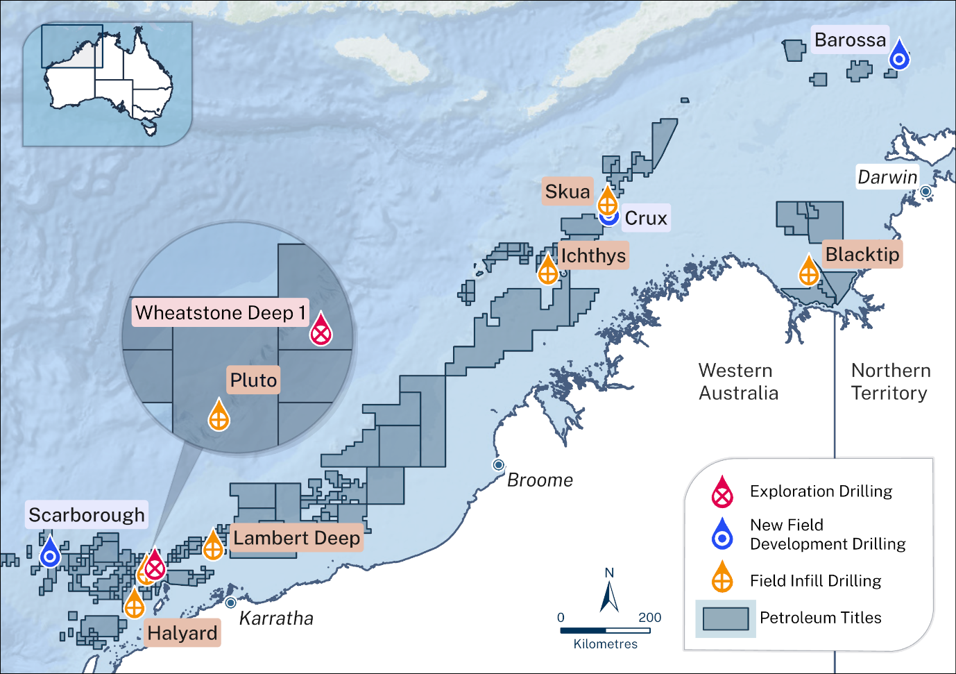
Figure 10: Petroleum drilling activity 2024-25 insights

Petroleum drilling activity in Northern WA - full text alternative figure 10
A regional map of Australia’s North West showing offshore petroleum titles and drilling activities during the reporting period. During 2024–25, the petroleum industry focused its exploration and development efforts on optimising existing discoveries and infrastructure within producing basins.
There are 6 locations of infill drilling. These are: Blacktip, Ichthys, Skua, Lambert Deep, Pluto, Halyard. There are 3 locations of new development drilling: Barossa, Crux and Scarborough. There is one location of exploration drilling: Wheatstone Deep.

Petroleum development milestones

September 2024
- Approval for 2 production licences were granted over Artisan (VIC/L35) and La Bella (VIC/L36). The 2 licences will deliver gas to supply Australia’s East coast
- The Lambert West field development plan was accepted

January 2025
- New guidance on the extended meaning of ‘explore’ was published on the website

March 2025
- A production licence application was received (currently under assessment)

June 2025
- 2 production licence applications were received (currently under assessment) as at 30 June 2025. These include:
  - 4 production licence applications pending Joint Authority decisions
  - a field development plan is under assessment.

Production – offshore basins
Australia’s total annual offshore production during the 2024-25 financial year remained stable (Figure 9). Over the past 5 years, production has held at near-record levels, supported by steady raw gas output linked to liquified natural gas (LNG) projects across across Australia’s North-Western basins. The focus on slowing production decline via ongoing development activity continues, including by infill drilling (especially for mature domestic gas projects) and tying back larger gas fields into existing LNG facilities.
The overall near-record levels continue to be underpinned by raw gas production and directly contrasts the oil production trends, where reported amounts reached a new record low during 2024. Despite efforts in mature projects to undertake infill drilling, this overall trend is unlikely to be reversed unless significant new investment occurs within emerging basins, such as the Roebuck sub-basin, or existing projects receive an economic boost via favourable international oil prices.
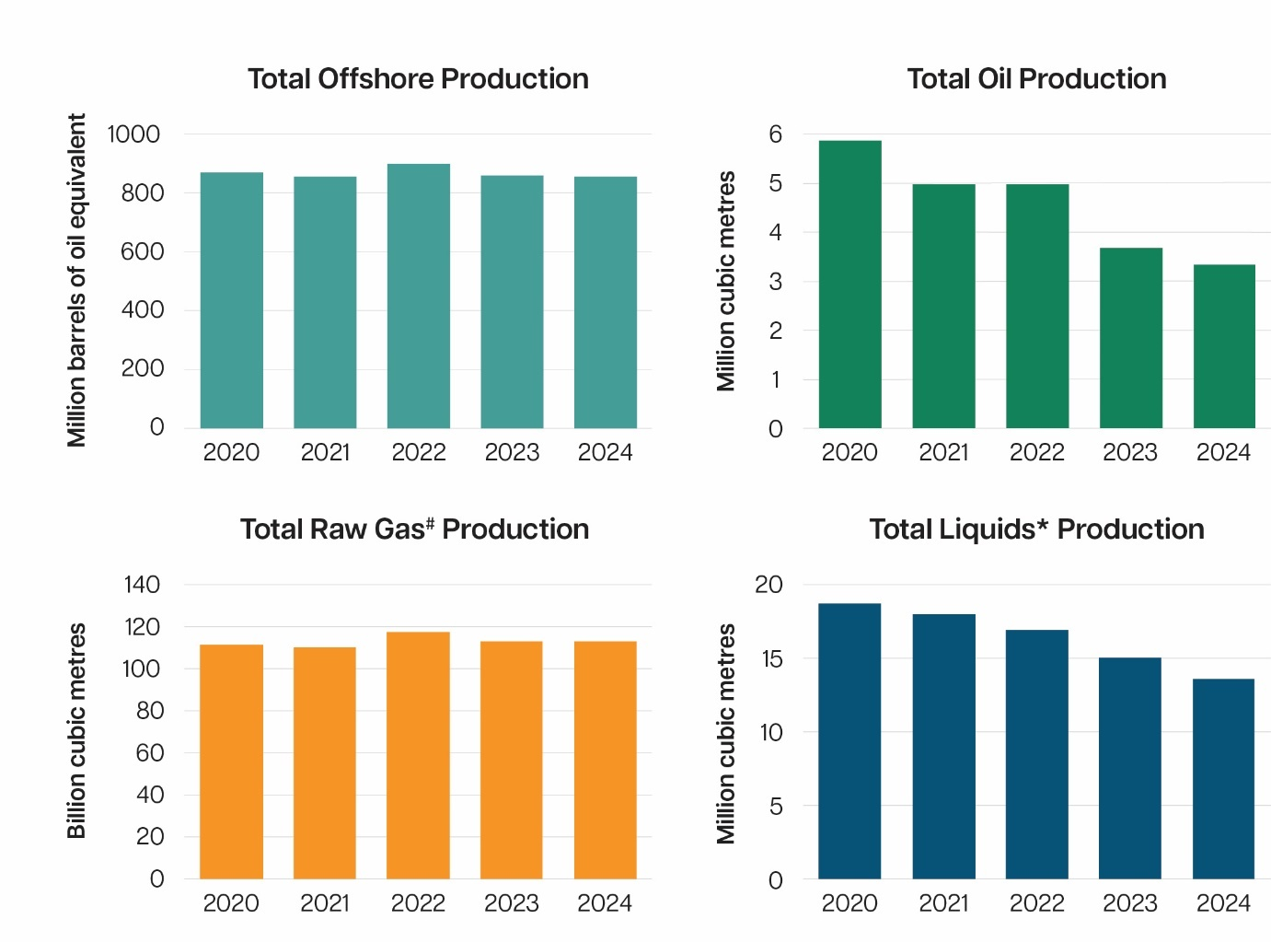
Figure 11: Australian offshore production trends for different resources, as reported to the Titles Administrator over the last 5 years

Australian offshore production trends – full alternative text, figure 11
Image comprises of the following 4 bar graph charts, positioned clockwise from top left:
Chart 1: Total offshore production
Vertical bar chart shows the total offshore production, measured in million barrels of oil equivalent (MMboe), for the 5 years from 2020 to 2024.
The chart shows that total production sat roughly between 850 and 900 for all 5 years, with the highest year of production at 900 million in 2022.
Chart 2: Total oil production
Shows the total oil production in million cubic metres for the 5 years from 2020 to 2024. The graph shows production declining steadily in the 5 years, with 6 million cubic metres produced in 2020, 5 for 2021 and 2022, 4 for 2023 and 3 for 2024.
Chart 3: Total raw# gas production
Vertical bar chart shows the production levels in millions cubic metres for the five years between 2020 to 2024. Raw gas production has remained stable between 110 and 120 million cubic metres, peaking in 2022.
Chart 4: Total liquids* production
Vertical bar chart shows the total liquids production for the 5 years from 2020 to 2024, measured in million cubic metres. Liquids include condensate, natural gas liquids and crude oil. This chart shows a gradual decline in production, with the year 2020 showing 19 cubic metres, 2021 with 18, 2022 with 17, 2023 with 15, and 2024 with the lowest production of 14 million cubic metres of production.

Production offshore basins - continued
In 2024, the Northern Carnarvon basin continued to be the largest source of raw gas and liquids (crude oil, condensate and natural gas liquids) production, accounting for 75% and 57% (respectively) of the total across offshore Australia (Figure 12).
The Browse basin remained the second largest contributor, representing 18% of total raw gas production, increasing slightly to account for 30% of total liquids production. The relative share from remaining offshore basins continued to decline, contributing approximately 7% of total raw gas and 13% of total liquids production.
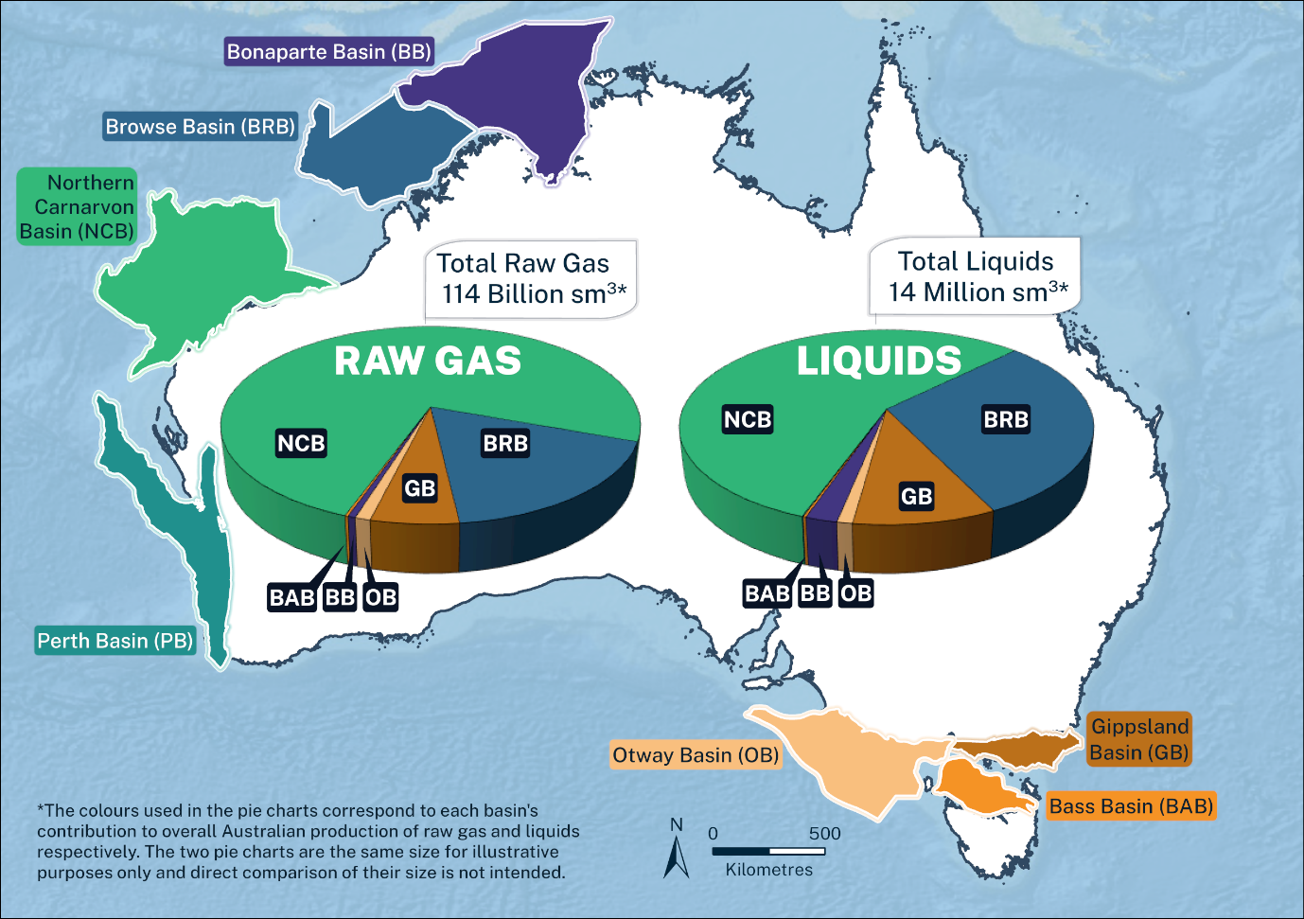
Figure 12: Australia's producing offshore basins and their relative contribution to total production in 2024
Australia’s producing offshore basins-full text alternativefigure 12
A national map showing annual offshore petroleum production volumes by sedimentary basin during the 2024–25 calendar year. The map includes two pie charts representing the contribution of each basin to Australia's overall production of raw gas and liquids. Colours used in the pie charts correspond to individual sedimentary basins. The pie charts are equal in size for illustrative purposes and are not to scale. Colour coding supports interpretation of each basin’s contribution to total annual production.
Basins along the coast of Western Australia and Northern Territory include Bonaparte, Browse, Northern Carnarvon and Perth. Basins along the coast of Victoria and South Australia include Otway, Bass and Gippsland.
Australia’s total raw gas production for the 2024–25 calendar year was approximately 114 billion standard cubic metres, while total liquids production was approximately 14 million standard cubic metres. The Northern Carnarvon basin contributed 75% of the nation’s raw gas output and more than half of its total liquids production.
Note on the map: the colours used in the pie charts correspond to each basin's contribution to overall Australian production of raw gas and liquids respectively. The 2 pie charts are the same size for illustrative purposes only and direct comparison of their size is not intended.

GHG storage activity
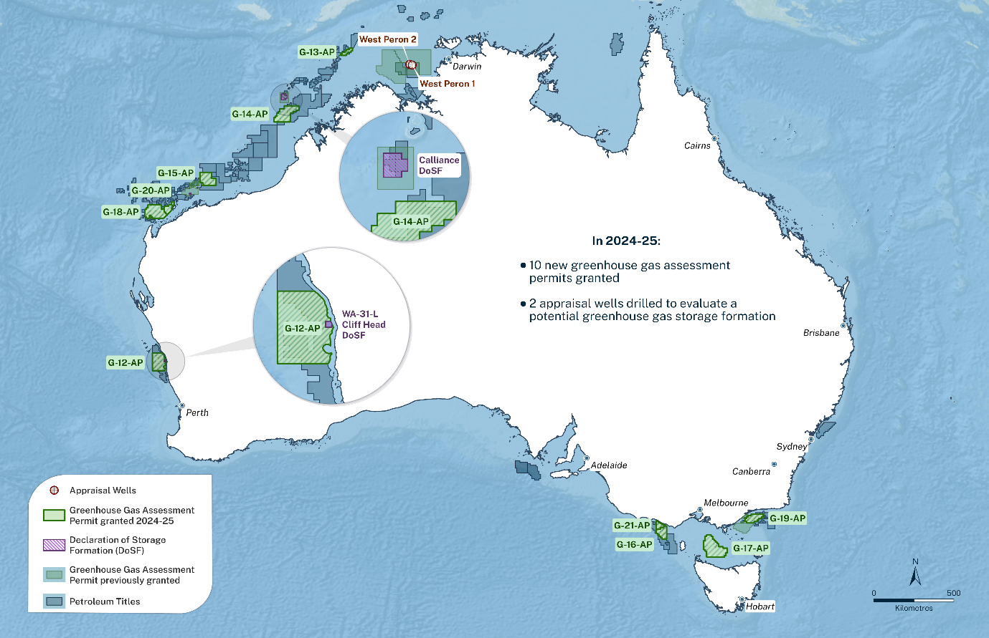
Figure 13: National map of offshore greenhouse gas permits and declared storage formations in Commonwealth waters

Australia’s offshore GHG activity in 2024-25 –full alternative text figure 13
A national map showing offshore greenhouse gas permits and declared storage formations in Commonwealth waters. The map includes visual overlays of appraisal wells and greenhouse gas permit areas, represented using distinct coloured shapes. Several greenhouse gas map features coexist with existing petroleum titles, illustrating spatial overlap between greenhouse gas and petroleum activities during the 2024–25 financial year. Colour coding supports interpretation of permit boundaries and activity types.
In Western Australian waters there were 6 Greenhouse Gas Assessment permits granted 2024-25, including G-12-AP, G-13-AP, G-14-AP, G-15-AP, G-18-AP and G-20-AP. There are also two Declaration of Storage Formations (DoSF) in West Australian waters. Calliance DoSF is in the north and WA-31-L Cliff Head DoSF in the south.
In Northern Territory waters, there are two Appraisal Wells, West Peron 1 and West Peron 2.
In Victorian waters there are four Greenhouse Gas Assessment permits granted in 2024-25, including G-16-AP, G-17-AP, G-19-AP and G-21-AP, and one Appraisal Well, Gular 1.
Text in the map states: ‘In 2024-25:
- 10 new greenhouse gas assessment permits granted
- 2 appraisal wells drilled to evaluate a potential greenhouse gas storage formation.

GHG storage activity insights
There were 17 GHG titles in Commonwealth waters, as at the 30 June 2025.
During the reporting period10 GHG assessment permits were granted in the Commonwealth offshore area. The permit areas include the Otway, North Carnavon, Gippsland, Bass, Browse, Bonaparte and Perth basins.

Applications submitted
During 2024-2025, a total of 21 applications were submitted.

Activity in the sector
In the last financial year, in addition to the 10 new GHG assessment permits granted, there were 8 dealings approved. There are several petroleum titleholders who are progressing towards gaining declarations of identified storage formations, which if declared would enable those projects to take the pathway to injection.

GHG administrative milestones 2024-25

Timeline
July 2024
- 1 GHG assessment permit granted (Perth basin).
August 2024
- 7 GHG assessment permit granted (Bass, Bonaparte, Browse, Gippsland, North Carnarvon (twice) and Otway basins).
December 2024
- 2 GHG assessment permit granted (Northern Carnarvon and Otway basins).
January 2025
- 4 new GHG factsheets on Injection Licence & Site Plan, Significant Risk of Significant Adverse Impact (SRoSAI), Risk Assessment & Monitoring Plans published online.

Declaration of an identified storage formation
The Declaration of a Storage Formation (DoSF) as an ‘identified GHG storage formation’ by the Responsible Commonwealth Minister, is a critical step in assessing the viability of a potential storage site for GHG injection and storage operations.
To be declared as an identified GHG storage formation, it must be deemed capable of permanently storing a particular amount of an injected GHG substance, injected over a period at specific injection points, with or without engineering enhancements, and with a suitable sealing mechanism.
Figure 14 shows the possible pathways for a DoSF to be declared, and the resulting titles. There are currently two DoSFs. A register of identified GHG storage formations can be found on the NEATS website.
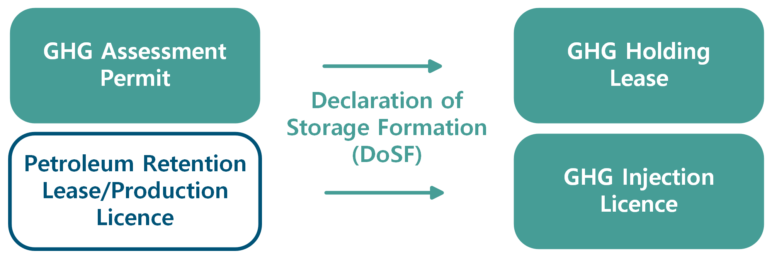
Figure 14: Pathways to a declaration of storage formation

Pathways to a declaration of Storage Formation diagram – full alternative text,figure 14
Flow diagram showing how it is possible to take the pathway to injection from either a ‘GHG assessment permit’ or a ‘petroleum retention lease/ production licence’ progressing to a ‘Declaration of Storage Formation’ and going on to a ‘GHG holding lease’ or ‘GHG injection licence’.

Governance and strategy

Governance
The branch fulfils its statutory roles as Titles Administrator and Registrar in line with the Australian government’s expectations for effective regulatory practice.
Guided by best practice principles outlined in the Resource Management Guide 128, the branch is committed to accountability, transparency, and proportionality in its decision-making.
These principles underpin our approach to stakeholder engagement, continuous improvement, and the delivery of timely, consistent, and risk-based regulatory advice, across Australia’s offshore energy sectors.

2024-2027 Strategic plan
The branch published its 2024-27 Strategic Plan in early 2024. The Strategic Plan operationalises the department’s corporate plan in relation to our functions across offshore petroleum, GHG and OEI sectors.
The strategic plan is supported by a comprehensive internal implementation program.
The Strategic Plan focuses on 4 key pillars:
- Resource stewardship: Provide responsible administrative and regulatory oversight of Australia’s offshore petroleum, greenhouse gas, and renewable energy resource projects.
- Leveraging information and technology: Improve and integrate our systems to enhance security, information, accessibility, and evidence-based decision making.
- Engagement: Enhance stakeholder engagement strategies to promote efficient and effective working relationships.
- Regulatory excellence: Foster and support a cost-efficient, high performing workforce, focused on continuous improvement, best practice outcomes and a positive workplace culture.

Pillar 1: Resource stewardship
Resource stewardship covers the full life cycle of petroleum, greenhouse gas (GHG) and OEI activities. The branch completes a range of functions to ensure titleholders’ actions align with Australian government policy objectives.
This includes promoting the efficient and timely resources development, monitoring titleholder performance and addressing emerging issues, such as late-life title management and project stewardship to support the energy transition.
The Titles Administrator monitors and analyses annual trends in offshore production as well as resources and reserves replacement.
Recent levels of total reserves replacement remain consistent with efforts to refine proved and probable volumes, with a slight relative improvement since 2022 (Figure15), without necessarily adding significant new volumes, such as from new fields, as was the case during the 2021 period.
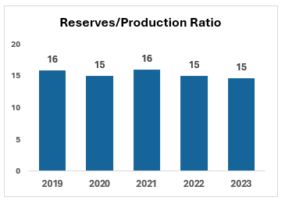
Figure 15: Reserves/production ratio by years, from 2019 to 2023
Reserves/production ratio by years 2019 to 2023- full alternative textfigure 15
This vertical bar graph shows the reserves-to-production ratio in the 5 years, from 2019 to 2023. This ratio indicates how many years proved reserves would last at that year’s production rate. The ratio has held steadily, at approximately 15 years, over the 5-year period.

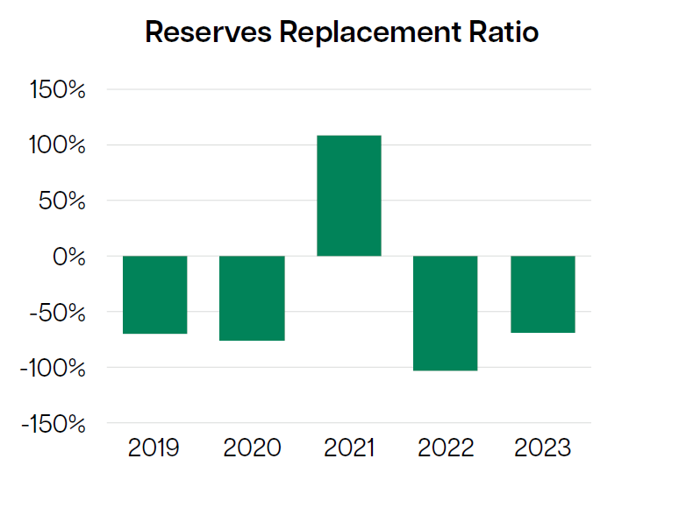
Figure 16: Annual trends in reserves replacement ratio from 2019 to 2023

Annual trends in reserves replacement ratio – full alternative text, figure 16
This vertical bar graph shows the reserves replacement ratio, as a percentage, from 2019 to 2023. All years record ratios below –50%, except 2022 at –100% and 2021 at +100%. A reserves replacement ratio shows whether annual additions to proved reserves keep pace with, exceed, or fall short of that same year’s reserves consumption.

Annual performance reviews and benchmarking
Annual performance meetings were held with all titleholders responsible for offshore production projects in 2024-25, both in face-to-face and online technical workshops and discussions formats.
These meetings tackled questions raised by the Titles Administrator through compliance monitoring, and provided valuable insights into well, field and project performance. This information complements data gained via annual reporting, and is used to assess various aspects of reservoir, field and facilities performance, with the process supporting the strategic advice to government regarding optimum recovery across Australia’s offshore basins.
The recent growth in greenhouse gas titles, and the growing increase in related data submitted to the Titles Administrator, shows there is an opportunity to build on this work and facilitate the ongoing stewardship of offshore energy resources.
This will be particularly important as Australian basins host a growing diversity of offshore energy projects.

Late life resources
As production matures across projects, the branch has maintained engagement with titleholders responsible for late-life projects, working to understand the current operational, commercial, financial and economic conditions.
A focus remains on ensuring that all opportunities to extend production are considered, as well as confirming anticipated cessation of production timing, and adequate and timely decommissioning planning for existing infrastructure.
During 2024-25, decommissioning planning and operational activity continued to occur, with various work scopes completed for projects in the Gippsland, Otway, Northern Carnarvon and Bonaparte basins.
There has been increased focus on understanding cessation of production timing, (actual) decommissioning costs and the methodology used to determine future cost estimates, which are part of titleholder engagements and reporting. The Titles Administrator is working with titleholders to increase consistency of both cost estimation and reporting, which will bring improved benchmarking efforts and more consistent advice to government.

Suitability assessment
Persons who wish to participate in Australia's offshore petroleum, greenhouse gas storage or energy infrastructure regimes as titleholders or licence holders must meet certain criteria, and this is tested upon entry into the regime and at major decision points thereafter. Decision makers need to consider many factors, including, but not limited to those shown in the list below.
Factors relevant to suitability assessments include:
- relevant experience
- financial resources
- technical advice
- compliance
- corporate governance
- other matters
- past performance.

Percentage of total applications requiring suitability assessments in 2024-25

Petroleum
A total 270 applications were submitted, of which:
- 22% required both a financial resources and technical advice assessment; and
- 7% required a compliance history and corporate governance assessment.
OEI
All 10 applications required both a financial resources and corporate governance assessment.

Greenhouse gas
A total of 21 applications were submitted, of which:
- 33% required a financial resources and technical advice assessment; and
- 19% required a history of compliance and corporate governance assessment.

Data management
The Titles Administrator has responsibility for the submission and release of documentary information and samples (petroleum and greenhouse gas data), in accordance with the Offshore Petroleum and Greenhouse Gas Storage (Resource Management and Administration) Regulations 2011 (RMA Regulations).
In 2024-25, the Titles Administrator:
- received 5,950 activity reports* (Figure 17)
- received 453 regulatory submission items** and
- authorised the public release of data from 87 activities, equal to 624TB of data.
The amount of data released has increased significantly, as compared to last financial year, from 14TB to 624TB. This is primarily due to the release of several large area surveys during the period.
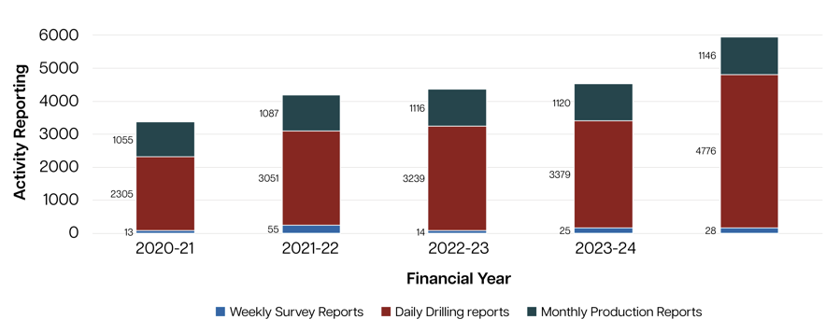
Figure 17: Number of activity reports received in 2020-21 to 2024-25
Activity reports received in 2020-21 to 2024-25 –full alternative text, figure 17
Table 9: Number of activities reports received in 2020-21 to 2024-25
Activity reporting | Financial year  2020-21 | Financial year 2021-22 | Financial year 2022-23 | Financial year 2023-24 | Financial year 2024-25
Weekly survey reports | 13 | 55 | 14 | 25 | 28
Daily drilling reports | 2305 | 3051 | 3239 | 3379 | 4776
Monthly production reports | 1055 | 1087 | 1116 | 1120 | 1146
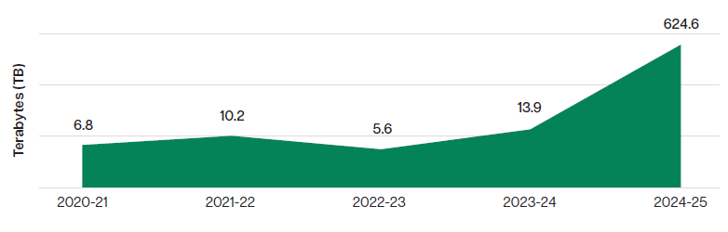
Figure 18: Open-file data release authorisations by financial year
Open-file data release for 2020-21 to 2024-25 - full alternative text, figure 18
Shaded line graph shows the amount of open-file data release authorisations in terabytes (TB) by financial year for the years 2020-21 to 2024-25. The annual release of data was:
  - 2020-21 – 6.8TB
  - 2021-22 – 10.2TB
  - 2022-23 – 5.6TB
  - 2023-24 – 13.9TB
  - 2024-25 – 624.6TB.

Pillar 2: Leveraging information and technology
NOPTA is enhancing its digital capabilities to strengthen security, improve data quality, and support evidence-based decision making. These efforts help to deliver a more seamless and user-friendly experience for stakeholders.
Our approach is built on:
- Integrated systems - connecting our technology platforms to enable better data integration and analysis. This integration will provide for more informed decisions and a smoother experience for users
- Strategic planning for the future - our 2024–2026 ICT Strategy sets a clear direction for digital capability development and governance, ensuring we keep pace in a rapidly evolving landscape
- Data quality and accessibility -ongoing improvements in data quality and accessibility are empowering users with reliable information and supporting greater transparency.
Updates to the NEATS, NOPIMS, and the Title Administrator and Registrar websites are helping to collaborate and introduce new ways to engage with stakeholders.

Pillar 3: Engagement
The Titles Administrator and Registrar have a diverse stakeholder footprint which cuts across industry, government, non-government and international agencies. We engage stakeholders through a variety of channels, including face-to-face contact, digital platforms, direct communications, and collaborative forums, to provide transparent and timely information sharing. Biennial surveys are held to measure stakeholder satisfaction across key areas of our functions.

Measuring engagement
We value engagement with our stakeholders and track our interactions across the financial year.
In 2024–25, the Titles Administrator had more than 900 interactions across the offshore petroleum, greenhouse gas, and offshore electricity infrastructure industries on administrative, operational, and regulatory matters. This number reflects an updated methodology for capturing stakeholder engagement.
Our stakeholder interactions are broken down by function below (Figure 19).
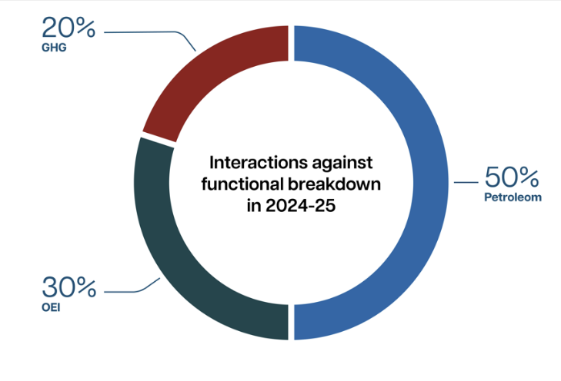
Figure 19: Interactions against functional breakdown in 2024-25
Chart with stakeholder interactions by function – full alternative text, figure 19
Pie chart shows the interactions against functional breakdown in 2024-25. The pie chart shows 3 parts, with half of the interactions with the petroleum sector at 50%, followed by the OEI sector at 30% and GHG sector at 20%.

International engagement
During the 2024-25, we continued to interact with our overseas equivalent regulators and participated in relevant international forums.
Senior leaders attended:
- the international upstream forum was held in St John’s, Canada in September 2024
- the Global Offshore Wind Regulators Forum (GOWRF) in Hamburg, Germany in October 2024
- the annual general meeting for the International Regulators Forum and International Offshore Petroleum Environmental Regulators in Ireland, in October 2024
- the Marine Resource Initiative Australia-Vietnam offshore wind symposium in Bac Lieu in December 2024. The symposium strengthened Australia’s engagement with Vietnam to advance offshore wind developments in the region and share lessons learned
- the Norwegian Offshore Directorate in Stavanger, Norway, and the North Sea Transition Authority in Aberdeen, Scotland in March/April 2025. The visit included a tour of the Northern Lights project near Bergen. The project is the world’s first cross-border carbon dioxide transport and storage facility.

2025 Stakeholder engagement – preparing for our next survey
As part of our commitment to continuous improvement and meaningful engagement, we started planning our seventh Stakeholder Survey during the reporting period. The survey was completed in the second quarter of 2025-26.
This survey’s focus was on the implementation of our Strategic Plan 2024-27 and aimed to capture insights from the diverse stakeholder networks of the Titles Administrator and Registrar.
The feedback gathered will help us refine our approach and ensure our strategic plan aligns with our stakeholder needs and delivers meaningful outcomes through to 2027.
Outcomes from the 2025 Stakeholder Survey are on the website and will be in next year’s annual report.

Pillar 4: Regulatory excellence
In 2024-25 the Titles Administrator:
- processed more than 453 regulatory data submission items and authorised the release of 89 data packages on wells and surveys
- held 14 annual field performance review meetings with titleholders for offshore petroleum production
- supported and collaborated with the department on reviews and amendments to the OPGGS Act and regulations
- assisted the department to consult on the regulatory framework for venting and flaring, and reviewed and updated guidelines to support the implementation of the Future Gas Strategy
- collaborated with the department to publish guidelines and factsheets for offshore greenhouse gas injection licences
- provided expert advice to the department on the policy reviews of offshore carbon capture and sequestration and offshore decommissioning.
In 2024-25 the Registrar:
- collaborated with the Department of Climate Change, Energy, the Environment and Water (DCCEEW) on the implementation of the licensing framework resulting in updates to relevant legislation and regulations
- developed regulatory guidance material to foster compliance with the OEI Act
- assisted DCCEEW to update the Transmission and Infrastructure Licence Guideline Chapter
- supported procedural fairness processes to unsuccessful feasibility licence applicants
- collaborated with the DCCEEW on the development of regulatory guidance material for the introduction of research and demonstration licences
- consulted with licence holders and published annual licence report guidance
- provided advice to licence holders on reporting and compliance across the framework.

External compliance monitoring
The Titles Administrator and the Registrar support compliance through guidelines, tailored assistance, and education, with an emphasis on voluntary compliance and early engagement to manage potential issues. Accountability for implementing and upholding the branch’s compliance and enforcement policy sits with every team.
In 2024-25, titleholders continued to show very high levels of voluntary compliance with the OPPGS Act, OEI Act and associated regulations. More than 96% of compliance requirements were met with only 3.74% recorded with non-compliance issues. This includes the late submission of Annual Titles Assessment Reports (ATARs) and the non-provision of documentation under Regulation 5.28 of the RMA regulations, which remain key areas of focus (see figure 20).
Compliance rates: 96% compliance, 4% non-compliance.
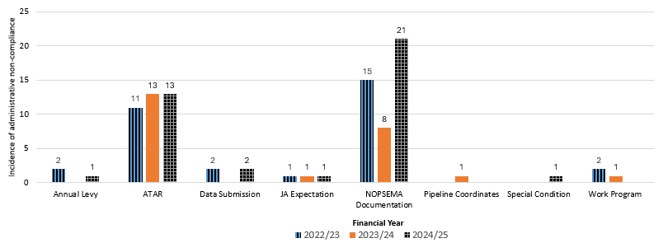
Figure 20: numbers of administrative non-compliance categories by year- comparison 2022-2025

Administrative non-compliance categories by year 2022/23 to 2024/25 – full alternative text, figure 20
Table 10: numbers of administrative non-compliance categories by year- comparision 2022 to-2025
Type of administrative non-compliance by year | 2022/23 | 2023/24 | 2024/25
Annual levy | 2 | 0 | 1
ATAR | 11 | 13 | 13
Data submission | 2 | 0 | 2
JA expectation | 1 | 1 | 1
NOPSEMA documentation | 15 | 8 | 21
Pipeline coordinates | 0 | 1 | 0
Special condition | 0 | 0 | 1
Work program | 2 | 1 | 0
FY totals | 33 | 24 | 39

Internal assurance reviews
Our internal assurance review program strengthens accountability by ensuring compliance with policies, procedures and guidance while driving efficiency across workflows. These quality measures provide assurance of reliability, accuracy and consistency, supporting continuous improvement and risk oversight.
In 2024-25 reviews were completed in the areas of:
- Change in control
- Register of licences
- ATARs
- 90% performance measure
- Communication strategy and framework
- New NOPIMS website
- Expiries and surrenders.

Performance outcomes

2024-25 performance
The Titles Administrator reports on its performance against a defined measure in the department’s corporate plan and annual report.
In 2024-25, it met the indicative target timeframes for assessing applications to the Joint Authority, Titles Administrator and Responsible Commonwealth Minister 99% of the time, in line with the department’s 90% target.
This result is not only the Titles Administrator’s highest result to date but also makes it five years of achieving 90% or over, since the 2020-21 reporting period.
Figure 20 shows the trended performance. These results demonstrates our ongoing commitment to improve efficiency.
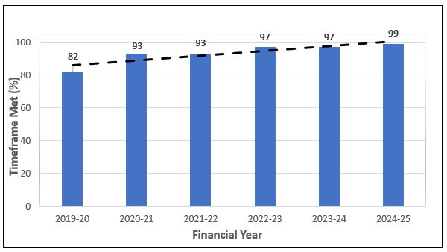
Figure 21: Percentage of applications that met the target assessment timeframes per financial year

Percentage of applications meeting the target assessment timeframes by financial year – full alternative text, figure 21
Vertical bar chart showing the percentage of applications that met the target assessment timeframes per financial year. It tracks the performance of the Titles Administrator in assessing applications under the Offshore Petroleum and Greenhouse Gas Storage Act (2006) over 6 reporting periods from 2019-20 through to 2024-25. Each bar in the chart represents one financial year.
The chart shows a consistent upward trend in performance, with the Titles Administrator improving year-on-year and maintaining a high level of efficiency in recent years, with the 99% result for the 2024-25 reporting period its highest result in its history.Percentage of assessment timeframes met by financial year were:
- 82% in 2019-20
- 93% in 2020-21
- 93% in 2022-23
- 97% in 2023-24
- 99% in 2024-25.
Figure 22 below shows the average number of days spent at each application stage for Joint Authority related applications in 2024-25.
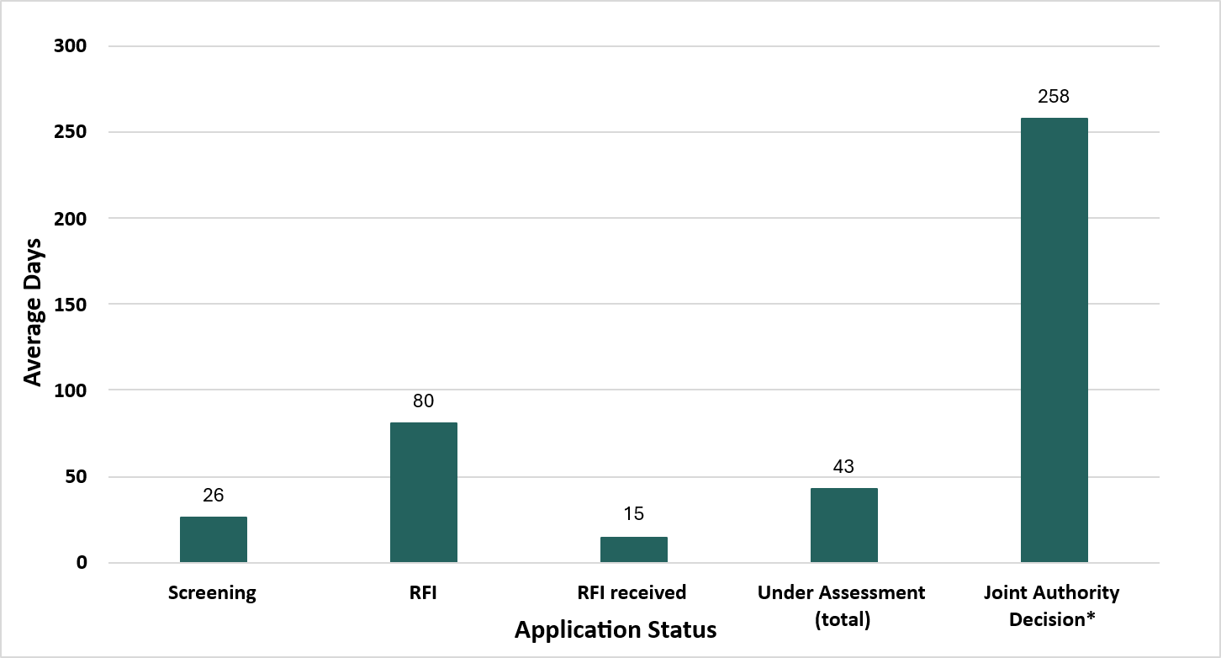
Figure 22: Completed Joint Authority applications (2024-25) average days spent at each major stage of application processing
Refer to footnote below.

Completed Joint Authority applications (2024-25) average days at each stage of application processing – full alternative text, figure 22
This vertical bar chart shows the average days spent at each major stage of application processing for Joint Authority related applications in the 2024-25 reporting period.
The x-axis lists the five key stages for application processing:
- screening
- request for further information (RFI)
- RFI received
- under assessment (total)
- Joint Authority decision.
The y-axis represents average duration in days, ranging from 0 to 300.
The chart shows the longest average processing time is with the Joint Authority, whilst screening and RFI received statuses were the smallest average timeframes.

Figure 23 below shows the average number of days at each major stage of application processing per Joint Authority application type during 2024-25.
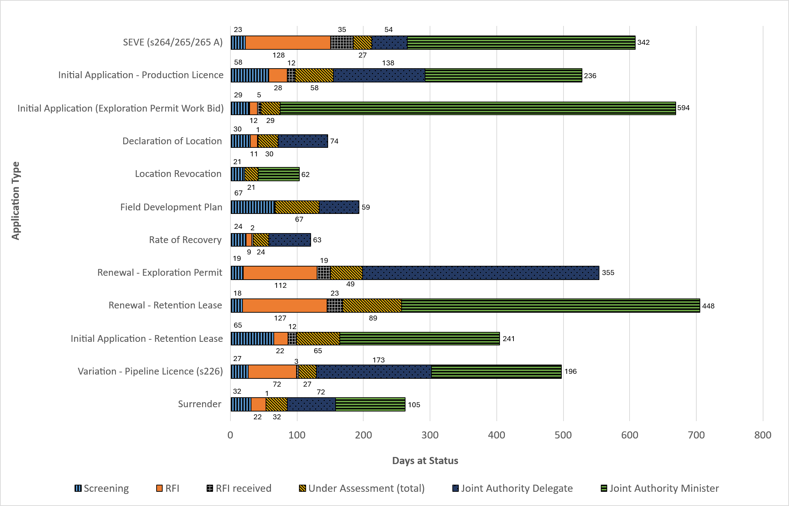
Figure 23: Completed Joint Authority applications (2024-25) - average days spent at each major stage of application processing by application type

Completed Joint Authority applications average days at each stage of application processing by application type – full alternative text, figure 23
Table 11: Completed Joint Authority applications (2024-25) - average days spent at each major stage of the application processing by application type
JA completed applications | Screening | RFI | RFI received | Under assessment (total) | JA delegate | JA minister
SEVE (s264/265/265 A) | 22.67 | 127.6 | 34.6 | 27.25 | 53.88 | 341.8
Initial application - production licence | 57.5 | 28 | 12 | 57.5 | 138 | 235.5
Initial application (Exploration Permit Work Bid) | 28.8 | 11.75 | 5 | 28.8 | 0 | 594.4
Declaration of location | 30 | 11 | 1 | 30 | 74 | 0
Location revocation | 21 | 0 | 0 | 21 | 0 | 62
Field development plan | 67 | 0 | 0 | 67 | 59 | 0
Rate of recovery | 23.5 | 9 | 1.5 | 23.5 | 63.25 | 0
Renewal - Exploration permit | 19.2 | 111.6 | 19.4 | 48.8 | 355.2 | 0
Renewal - Retention lease | 18.25 | 126.83 | 23.17 | 89.17 | 0 | 448.42
Initial application - Retention lease | 65 | 22 | 12 | 65 | 0 | 241
Variation - Pipeline licence (s226) | 26.55 | 72.36 | 3.36 | 26.55 | 173 | 196
Surrender | 31.5 | 21.5 | 1 | 31.5 | 72.2 | 105
Total average | 26.32 | 80.45 | 14.82 | 43.05 | 121.97 | 352.92

Figure 24 below shows the average number of days spent at each application stage for Titles Administrator related applications in 2024-25.
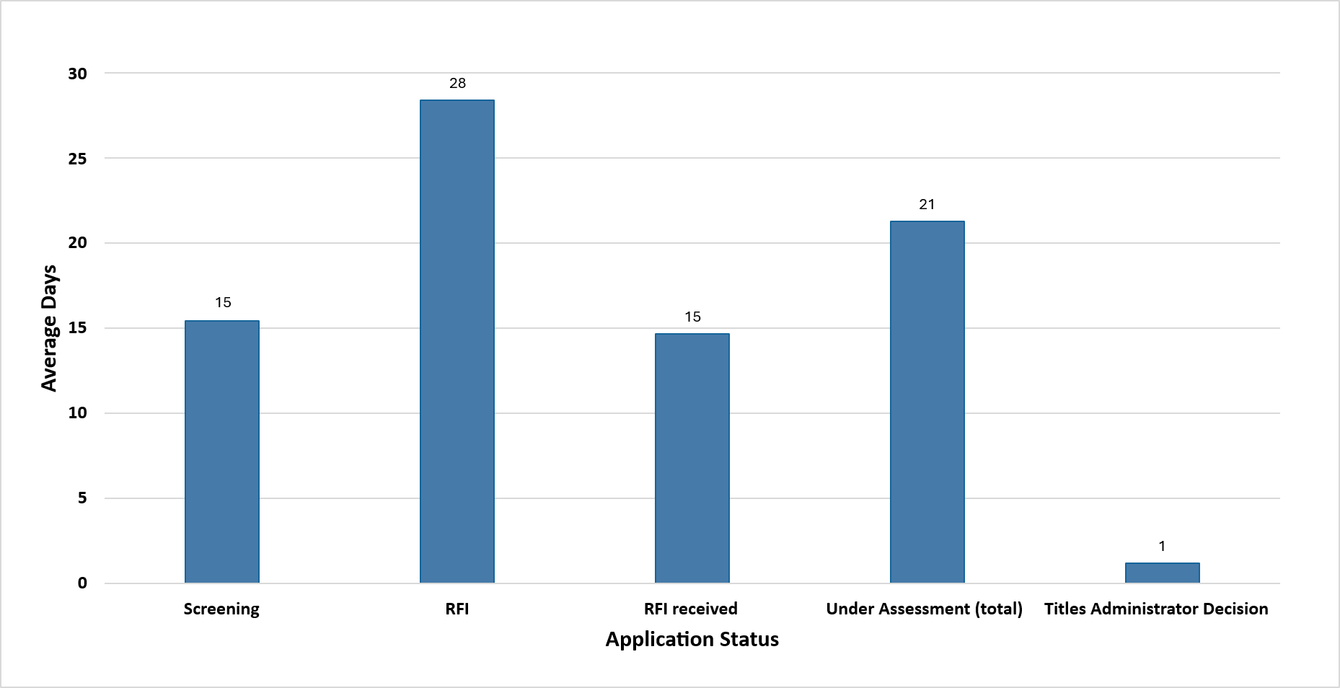
Figure 24: Completed Title Administrator applications (2024-25) - average number of days spent at each major stage of application processing

Completed TA applications (2024-25) average number of days at each major stage of application processing – full alternative text, figure 24
Vertical bar chart, shows the average number of days spent at each major stage of application processing’, shows the average time taken at each stage of the application process in the 2024-25 reporting period.
The x-axis lists the 5 key stages for Titles Administrator application processing:
- Screening
- RFI
- RFI received
- Under assessment (total)
- Titles Administrator decision.
The y-axis represents average duration in days, ranging from 0 to 30. The chart shows the longest average processing time is with the RFI, while the Titles Administrator decision has the smallest average timeframe.

Figure 25 below shows the average days at each major stage of application processing per Titles Administrator application type during 2024-25.
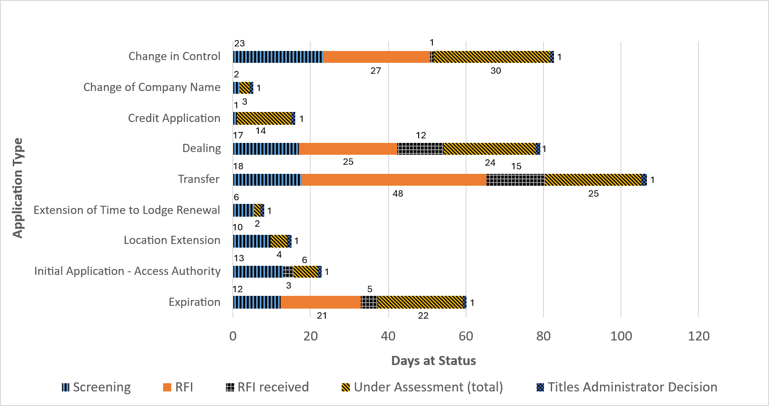
Figure 25: Completed Titles Administrator Applications (2024-25) - days at status at each major stage of application processing by application type

Completed TA applications days at status at each stage of application processing by application type – full alternative text, figure 25
Table 12: Completed Titles Administrator Applications (2024-25) - days at status at each major stage of application processing by application type
TA completed applications | Screening | RFI | RFI received | Under assessment (total) | Titles administrator decision
Change in control | 23.4 | 27.33 | 1 | 30 | 1
Change of company Name | 1.75 | 0 | 0 | 2.5 | 1
Credit application | 1 | 0 | 0 | 14 | 1
Dealing | 16.92 | 25.46 | 12 | 23.65 | 1.18
Transfer | 17.65 | 47.75 | 15.05 | 24.8 | 1.3
Extension of time to lodge renewal | 5.5 | 0 | 0 | 1.5 | 1
Location extension | 9.75 | 0 | 0 | 4.25 | 1
Initial application - Access authority | 13 | 0 | 2.67 | 6.14 | 1
Expiration | 12.25 | 20.75 | 4.5 | 21.75 | 1
Total average | 15.44 | 28.34 | 14.63 | 21.23 | 1.15

Figure 26 shows the average days spent at each application stage for Responsible Commonwealth Minister GHG related applications in 2024-25.
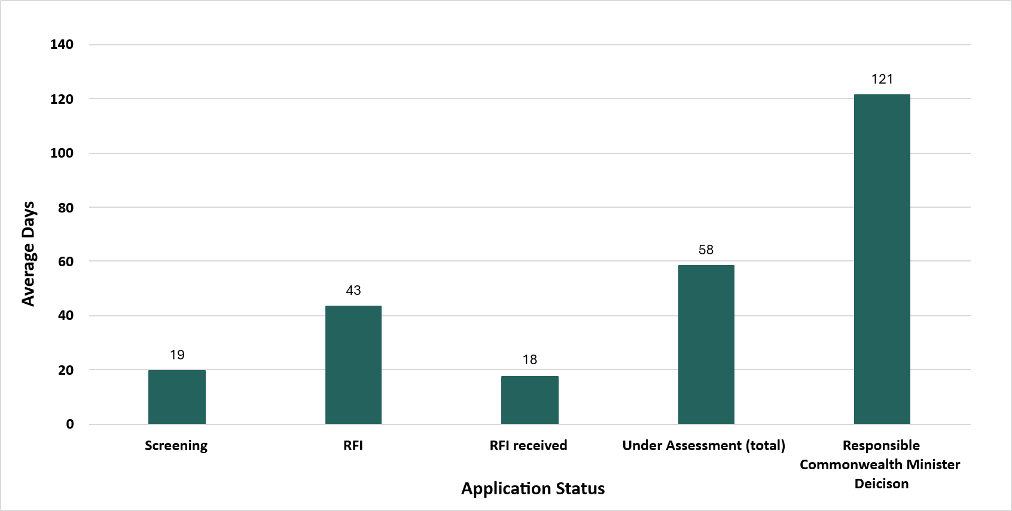
Figure 26: Completed Responsible Commonwealth Minister Applications (2024-25) – average days spent at each major stage of application processing

Completed RCM applications (2024-25) average days at each stage of application processing - full alternative text, figure 26
This vertical bar chart shows the average days spent at each major stage of application processing for the Responsible Commonwealth Minister application process during the 2024-25 reporting period.
The x-axis lists the five key stages for Titles Administrator application processing:
- Screening
- RFI
- RFI received
- Under assessment (total)
- Responsible Commonwealth Minister decision.
The y-axis represents average duration in days, ranging from 0 to 140.
The chart shows the longest average processing time is with the Responsible Commonwealth Minister, whilst the Screening and RFI received statuses show the smallest average timeframes.

Application process overview
The diagram below outlines the Australian Government’s process for offshore petroleum, GHG and OEI decisions under the OPGGS Act and OEI Act.
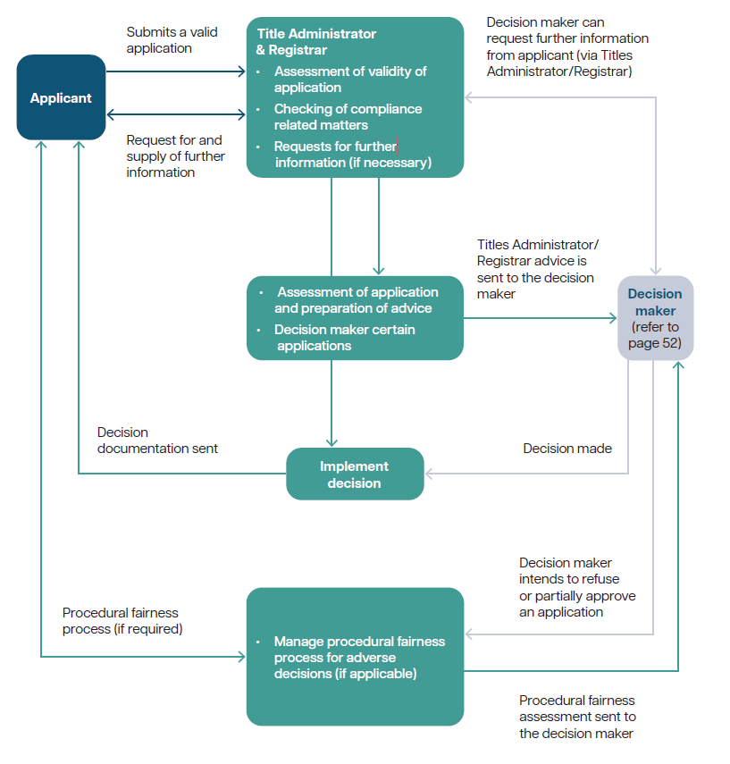
Figure 27: Application process model under the OPGGS Act and OEI Act
Application process model under the OPGGS Act and OEI Act – full alternative text, figure 27
Diagram of the application process flowchart. The broad process is below. Throughout the application process exceptions might occur and numerous interactions may happen at each stage.
The applicant submits a valid application to the Titles Administrator and Registrar. After this the Titles Administrator and Registrar reviews:
- Assessment of validity of application
- Checking of compliance related matters
- Requests for further information (if necessary).
If this is deemed suitable – the following occurs:
- An assessment of application and preparation of advice will be prepared.
- Some will be referred to the decision maker, who will look at these applications.
After this the Titles Administrator/Registrar will receive advice from the decision maker who may:
- request further information from the applicant (via TA/Registrar)
- They may make a decision, whereby the TA/ Registrar will implement this decision, and decision documentation will be communicated. Or the decision maker may refuse or partially approve an application.
The TA will then:
- manage procedural fairness process for adverse decisions (if applicable)
- give a procedural fairness assessment to the decision maker.
It is possible that even after some interaction an application might be returned to the applicant and further documentation is required. Equally the decision maker may still request more information.
Even when applications are not successful, there is a procedural fairness process for adverse decisions that would work with both the applicant and the decision maker, to ensure that both parties are aware of expectations in the application process.

Who does what in government?

Whole of government overview
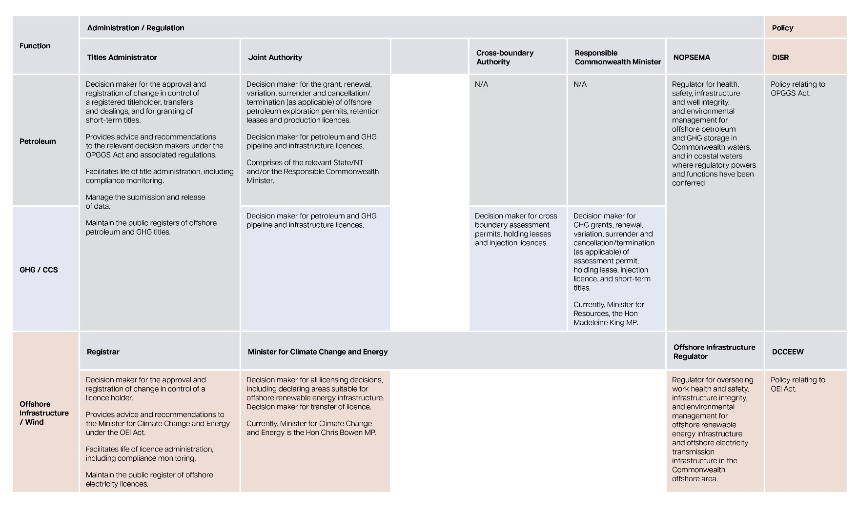
Figure 28: A whole-of-government table outlining the roles of key entities in 3 sectors

Whole-of-government table outlining the roles of key entities in 3 sectors - full alternative text, figure 28
Figure 28 is a whole-of-government table outlining the roles of key entities across petroleum, greenhouse gas and offshore renewable infrastructure,containing key roles and responsibilities in administration, regulation, and policy under the OPGGS Act and OEI Act, including Titles Administrator, Registrar, and regulator responsibilities.

Petroleum
Titles Administrator functions:
- Decision maker for the approval and registration of change in control of a registered titleholder, transfers and dealings, and for granting of short-term titles.
- Provides advice and recommendations to the relevant decision makers under the OPGGS Act and associated regulations.
- Facilitates life of title administration, including compliance monitoring.
- Manage the submission and release of data.
- Maintain the public registers of offshore petroleum and GHG titles.
Joint Authority:
- Decision maker for the grant, renewal, variation, surrender and cancellation/termination (as applicable) of offshore petroleum exploration permits, retention leases and production licences.
- Decision maker for petroleum and GHG pipeline and infrastructure licences.
- Comprises of the relevant State/NT and /or the Responsible Commonwealth Minister.
Cross-boundary authority: not applicable.
Responsible Commonwealth Minister: not applicable.
NOPSEMA: Regulator for health, safety, infrastructure and well integrity, and environmental management for offshore petroleum and GHG storage in Commonwealth waters, and in coastal waters where regulatory powers and functions have been conferred.
Department of Industry, Science and Research: is responsible for policy relating to OPGGS Act.

Greenhouse gas/carbon capture storage
Titles Administrator functions:
- Decision maker for the approval and registration of change in control of a registered titleholder, transfers and dealings, and for granting of short-term titles.
- Provides advice and recommendations to the relevant decision makers under the OPGGS Act and associated regulations.
- Facilitates life of title administration, including compliance monitoring.
- Manage the submission and release of data.
- Maintain the public registers of offshore petroleum and GHG titles.
Joint Authority:
- Decision maker for petroleum and GHG pipeline and infrastructure licences.
Cross-boundary Authority:
- Decision maker for cross boundary assessment permits, holding leases and injection licences.
Responsible Commonwealth Minister:
- Decision maker for GHG grants, renewal, variation, surrender and cancellation/termination (as applicable) of assessment permit, holding lease, injection licence and short term titles.
- Currently, Minister for Resources, the Honourable Madeleine King MP.
NOPSEMA:
- Regulator for health, safety, infrastructure and well integrity, and environmental management for offshore petroleum and GHG storage in Commonwealth waters, and in coastal waters where regulatory powers and functions have been conferred.
Department of Industry, Science and Research is responsible for all policy relating to the OPGGS Act.

Offshore infrastructure/wind
OEI Registrar:
- Decision maker for the approval and registration of change in control of a licence holder.
- Provides advice and recommendations to the Minister for Climate Change and Energy under the OEI Act.
- Facilitates life of licence administration, including compliance monitoring.
- Maintain the public register of offshore electricity licences.
Minister for Climate Change and Energy:
- Decision maker for all licensing decisions, including declaring areas suitable for offshore renewable energy infrastructure. Decision maker for transfer of licence.
- Currently, Minister for Climate Change and Energy, the Hon Chris Bowen MP.
Offshore Infrastructure Regulator:
- Regulator for overseeing work health and safety, infrastructure integrity, and environmental management for offshore renewable energy infrastructure and offshore electricity transmission infrastructure in the Commonwealth offshore area.
Department of Climate Change, Environment, Energy and Water:
- Policy relating to the OEI Act.

Financials

OPGGS Act – Cost recovery overview
The Titles Administrator’s functions are fully funded by levies and fees charged for administering the offshore petroleum and GHG storage titles under the OPGGS Act.
Its current cost recovery arrangements are detailed in the 2025 Cost Recovery Implementation Statement (CRIS). The funds are managed through an administered Special Account in line with the requirements of the Public Governance, Performance and Accountability Act 2013 (PGPA Act).

Levies
In 2024-25, $16.4 million was collected in levies, making up 85% of NOPTA’s revenue (see Table 13).
The levy, prescribed in the Offshore Petroleum and Greenhouse Gas Storage (Regulatory Levies) Regulations 2022, is payable upon the grant of a title and is due annually thereafter within 30 days of the anniversary date of the title.
Table 13: Annual titles administration levy 2024-25
Title type | No. of titles | No. of blocks | Length in km | Levy amount $’000
Exploration permits | 68 | - | - | 775
Exploration permits adjustment | 5 | - | - | 26
Refund of surrendered exploration permits | 6 | - | - | -66
Refund of withdrawal exploration permits | 1 | - | - | -11
Greenhouse gas assessment permit | 17 | - | - | 187
Infrastructure licence | 3 | - | - | 85
Pipeline licence | 87 | - | 4822 | 563
Production licence | 98 | 325 | - | 7,385
Production licence surrender | 1 | 5 | - | -110
Retention lease | 71 | 313 | - | 7,321
Retention lease adjustment | 7 | 11 | - | 239
Refund of expired retention lease | 1 | - | - | -8
Total annual levy |  |  |  | 16,386

Fees
Application fees, prescribed in the Offshore Petroleum and Greenhouse Gas Storage (Resource Management and Administration) Regulations 2011, are payable when submitting applications for approval to undertake certain regulated activities. In 2024-25, application fee revenue was $2.9 million, making up 15% of total revenue (see Table 14).
Table 14: Application fees for 2024-25
Application type | No. of Applications | Fee amount $’000
Renewal exploration permit | 3 | 44
Petroleum retention lease | 3 | 59
Renewal retention lease | 8 | 152
Production licence | 3 | 76
Variation pipeline licence | 2 | 26
Transfer | 10 | 86
Dealing | 159 | 1,524
Change in control | 8 | 69
Access authority | 5 | 38
Suspension, extension, variation, exemption | 20 | 311
Declaration of location | 2 | 34
Surrender | 14 | 164
Acceptance of FDP | 1 | 26
Rate of recovery | 5 | 76
Declaration of identified storage formation | 2 | 17
GHG variation, suspension, exemption | 3 | 54
GHG transfer | 4 | 40
GHG dealing | 12 | 111
Total application fees | 264 | 2,907

OPGGS Act - cost effectiveness and financial results
Since the Titles Administrator is a branch within DISR, its functions are legislated under the OPGGS Act. This provides a clear separation from DISR, and enables easy identification of the costs recovered from industry.
DISR provides the governance structure, access to corporate support and systems, and pays workers’ compensation and other insurances. It also charges directly attributable costs to the Administrator. In 2024-25, $1.1 million was recovered for Titles Administrator operations and $0.2 million for Registrar functions.
During the 2024-25 financial year, ICT capital expenditure totalled $1.86 million. The Titles Administrator’s Special Account balance was $5.8 million as of 30 June 2025.
Table 15: Our 2024-25 financial results for revenue -cost recovery compared to 2023-24
Income statement - Revenue - cost recovery | 2024-25  $'000 | 2023-24  $'000
Levies | 16,386 | 15,690
Application fees | 2,907 | 1,964
Other | 32 | 53
Total revenue | 19,325 | 17,706

Table 16: Our 2024-25 financial result for expenses compared to 2023-24
Income statement - Expenses | 2024-25  $'000 | 2023-24  $'000
Employee benefits | 12,664 | 11,045
Suppliers | 3,081 | 3,740
NOPDCR | 1,410 | 1,382
ICT and telecommunications costs | 1,433 | 1,943
Depreciation and amortisation | 1,890 | 1,228
Overhead recharging allocation | 763 | 773
Total expenses | 21,241 | 20,111

Table 17: Our 2024-25 financial result for surplus/ (deficit) compared to 2023-24

Income statement | 2024-25  $'000 | 2023-24  $'000
Surplus / (deficit) | (1,916) | (2,405)

OEI Act – cost recovery overview
The Registrar’s functions under the OEI Act is upheld by access to adequate resources and qualified personnel. The Registrar maintains a competent capacity to undertake its advisory and compliance roles within the OEI regime. Funding for the Registrar is provided through the cost recovery charges imposed under the OEI legislation, with funds managed through an administered Special Account.
Tables 18, 19 and 20 presents the financial performance for 2024-25 compared to 2023-24. The Registrar’s cost recovery is achieved through application fees and annual licence levies. In 2024-25, the total annual licence levy collected was $2.1 million (Table 18).
The annual licence levy is imposed on holders of OEI licences in accordance with the OEI Act, the Offshore Infrastructure (Regulatory Levies) Act 2021, and the Offshore Electricity Infrastructure (Regulatory Levies) Regulations 2022. The annual levy is payable 30 days after a licence is granted and annually thereafter within 30 days of each licence anniversary.
Application fees, as prescribed by the Offshore Electricity Infrastructure Regulations 2022, are payable at the time of application submission. In 2024-25, application fee revenue totalled $2.2 million (Table 18).
Table 18: Registrar's financial performance for revenue in 2024-25 compared to 2023-24
Income statement- Revenue - cost recovery | 2024-25  $’000 | 2023-24  $’000
Levies | 2,095 | 953
Application fees | 2,207 | 2,400
Other | 1 | -
Revenue - other
Fees collected on behalf of other agencies | 6,673 | 3.080
Total revenue | 10,976 | 6,433

Table 19: Registrar's financial performance for expenses in 2024-25 compared to 2023-24
Income statement - Expenses | 2024-25  $’000 | 2023-24  $’000
Employee benefits | 3,748 | 1,780
Suppliers | 1,941 | 1,790
Depreciation and amortisation | 63 | 21
Overhead recharging allocation | 1,432 | 121
Total expenses | 7,184 | 3,712
Table 20: Registrar's financial performance for surplus/ (deficit) in 2024-25 compared to 2023-24
Income statement | 2024-25  $’000 | 2023-24  $’000
Surplus / (deficit) | 3,792 | 2,721

OEI Act - cost effectiveness and financial results
The Registrar uses a range of services provided by the Titles Administrator to support its functions. The main costs comprise of the Registrar’s portion of office accommodation and utility costs, ICT network and desktop costs, operating costs and depreciation of office fit-outs.
To make sure the Registrar remains fully cost recovered, the costs incurred by the Administrator are reimbursed. In 2024-25, the allocation of these costs totalled $1.2 million. DISR provides the governance structure, access to corporate support and systems, workers’ compensation and other insurances.
On 30 June 2025, the balance of the Registrar’s Special Account was $13.39 million. The special account balance consists of financial securities held and levies collected on behalf of DCCEEW.

- the *** asterix is Ashmore and Cartier Islands (AC): A remote external territory of Australia in the Timor sea. - the double ** asterix is Bayu-Undan (BU): A former offshore gas field in the Timor sea, previously operated under a transitional treaty arrangement between Australia and Timor-Leste. - * a single asterix footnote on the ‘Other’ category is an aggregated segment for less frequent application submissions, including Credit and Extension of time to Lodge Renewal.
* includes Suspensions, Extensions, Variations and Exemptions ** includes Cancellation, Cease to Operate - Temporary, Equipment & Procedures, Field Development Plan, Rate of Recovery *** includes Declaration of Location and Location Revocation.
# Raw gas is gas produced offshore from the full wellstream minus water content and condensate recovered from offshore facilities.
*Liquids includes condensate, natural gas liquids and crude oil.
*Includes: 1,146 production reports, 4,776 drilling reports, 28 survey reports.
**Includes: 313 wells and 140 survey data items
*includes overall time spent at both respective state and Commonwealth decision makers

