

Offshore petroleum declaration of location
  - Guideline
9 December 2025
Our purpose is to help the government build a better future for all Australians through enabling a productive, resilient and sustainable economy, enriched by science and technology.
| www.nopta.gov.au

Copyright
© Commonwealth of Australia 2025
Ownership of intellectual property rights
Unless otherwise noted, copyright (and any other intellectual property rights, if any) in this publication is owned by the Commonwealth of Australia.

Creative Commons Attribution 4.0 International Licence CC BY 4.0
All material in this publication is licensed under a Creative Commons Attribution 4.0 International Licence, with the exception of:
- the Commonwealth Coat of Arms
- content supplied by third parties
- logos
- any material protected by trademark or otherwise noted in this publication.
Creative Commons Attribution 4.0 International Licence is a standard form licence agreement that allows you to copy, distribute, transmit and adapt this publication provided you attribute the work. A summary of the licence terms is available from https://creativecommons.org/licenses/by/4.0/. The full licence terms are available from https://creativecommons.org/licenses/by/4.0/legalcode.
Content contained herein should be attributed as the Offshore petroleum declaration of location guideline.
This notice excludes the Commonwealth Coat of Arms, any logos and any material protected by trademark or otherwise noted in the publication, from the application of the Creative Commons licence. These are all forms of property which the Commonwealth cannot or usually would not licence others to use.

Disclaimer
The purpose of this publication is to provide information on the processes set out in the Offshore Petroleum and Greenhouse Gas Storage Act 2006 (OPGGS Act) to declare, vary and revoke a location. It also seeks to assist applicants and titleholders to understand the expectations of the Joint Authority when making decisions in respect to locations.
The Commonwealth as represented by the Department of Industry, Science and Resources has exercised due care and skill in the preparation and compilation of the information in this publication.
The Commonwealth does not guarantee the accuracy, reliability or completeness of the information contained in this publication. Interested parties should make their own independent inquires and obtain their own independent professional advice prior to relying on, or making any decisions in relation to, the information provided in this publication.
The Commonwealth accepts no responsibility or liability for any damage, loss or expense incurred as a result of the reliance on information contained in this publication. This publication does not indicate commitment by the Commonwealth to a particular course of action.

Contents
1. Overview 2
Decision-maker 2
Submission requirements 2
2. Effects of a declared location on an exploration permit 4
3. Process for declaring a location 5
Suggested information to be provided to support a nomination to declare a location 5
Assessment and decision making 7
Application period 8
Timing 9
4. Variation of a declared location 10
5. Revocation of a declared location 11
Blocks no longer part of an exploration permit, retention lease or production licence 11
6. Flowchart for declaring a location 12
7. Table of revisions 13

Overview
  - The purpose of this publication is to provide information on the processes to declare, vary and revoke a location pursuant to the Offshore Petroleum and Greenhouse Gas Storage Act 2006 (the OPGGS Act). It seeks to assist petroleum exploration permittees to understand the expectations of the Joint Authority when making decisions on applications.
  - A location provides the mechanism for the transition from an exploration permit to a retention lease or production licence following the discovery of petroleum. It is not a title; rather, it is a means of setting aside and identifying the graticular block or blocks within the permit necessary to cover the discovery from which the permittee may select the block or blocks to form a retention lease or production licence area.
  - A block or blocks can be nominated as a location by the permittee, or the Joint Authority can require the permittee to nominate blocks.
  - Retention lease and production licence applications may only be made over a block or blocks comprising a declared location. If two or more blocks are declared as a location, an application for a retention lease or a production licence may be made over some or all of the blocks that comprise the declared location.
  - If the permittee has discovered petroleum through the drilling of a well, they must notify NOPTA of the discovery within 30 days after the completion of the well. There is no ability to extend this deadline—section 284 of the OPGGS Act.
  - Section 6 of this guideline contains a flow chart illustrating the processes for obtaining either a retention lease or production licence over a block or blocks covered by a declared location.
For information about the obligations for notifying and reporting the discovery of petroleum, including discovery notification and discovery assessment reports, please refer to Part 2 of the Offshore Petroleum and Greenhouse Gas Storage (Resource Management and Administration) Regulations 2011 (RMA Regulations) and the Petroleum Discoveries Fact Sheet on the NOPTA website.

Decision-maker
  - The relevant offshore petroleum Joint Authority is the decision maker on a nomination for the declaration of location.
    - The Joint Authority for an offshore area of a State (other than Tasmania) comprises the responsible Commonwealth Minister and the responsible State Minister. The responsible Commonwealth Minister is the Joint Authority for the offshore area of Tasmania and the Territory of Ashmore and Cartier Islands. The responsible Commonwealth Minister and the responsible Northern-Territory Minister comprise the Commonwealth-Northern Territory Offshore Petroleum Joint Authority.
  - Applications are assessed by NOPTA and advice is provided to the relevant Joint Authority.
Matters relating to the assessment of the suitability of an applicant can be found in the Guideline: Applicant suitability.

Submission requirements
  - Nominations must be:
    - on a completed application form (made in writing).
    - accompanied by the application fee.
The application fee for this application can be found on NOPTA’s website. Please refer to the application form for details and submission information on NOPTA’s website.
For further information on submission requirements refer to the NOPTA Forms Guidance–Petroleum.

Effects of a declared location on an exploration permit
  - A block or blocks comprising a declared location remain part of the exploration permit and are subject to the permit conditions, including the minimum work program requirements.
  - A block or blocks not subject to a declared location, including blocks removed from the declared location by variation or revocation—see sections 4 and 5 of this guideline—also remain in force within the exploration permit, and are subject to the permit conditions.
  - A block or blocks declared as a location can be retained in the renewed exploration permit under the standard halving rules set out in section 123 (5) of the OPGGS Act.
  - A block or blocks that are no longer within a declared location, as a result of either revocation of the entire location or variation resulting in the deletion of a block from the location will lose the benefit described above under the halving rules under the OPGGS Act.
For further information about renewing an exploration permit please refer to NOPTA’s website, including the Offshore Petroleum Exploration Work-bid Guideline and the Renewal of Work-Bid Exploration Permits-Standard Halving Rules fact sheet.

Process for declaring a location

Suggested information to be provided to support a nomination to declare a location
Permittees should include the following information for each nomination.

Supporting information
  - A discussion of the regional exploration completed to date.
  - A detailed discussion of the geological setting of the identified petroleum pool(s), especially within the exploration permit where it is located.

Exploration context of permit and pool(s) under consideration
  - Title summary, which includes a short summary of the title ownership and exploration work program.
  - Exploration and discovery history:
    - wells drilled.
    - well results.
    - adjacent fields.
  - Geological setting:
    - play types.
    - petroleum systems:
      - trap types.
      - reservoirs, seals.
      - source rocks.
      - stratigraphy.
  - Petroleum pool(s):
    - trapping mechanism(s).
    - reservoirs, seals.
    - estimated hydrocarbon volumes in place and estimate of recoverable hydrocarbons.
  - A schedule of activities that will be conducted during the two year application period to assess the commerciality of the petroleum discovery and progress to an application for production licence or retention lease.

Petroleum pool(s)
  - Recoveries and types of petroleum recovered:
    - nature of testing; volumes recovered.
    - formation(s) from which petroleum was recovered.
    - depths of hydrocarbon recoveries and pressure tests.
    - validity of tests and recoveries.
  - Nature of hydrocarbons recovered; analyses and compositions of hydrocarbons recovered.
  - Pressure system(s) present.
    - All available pressure data including any identified or interpreted fluid contacts, such as hydrocarbon-water contacts.
  - Evidence for compartmentalisation in pool and aquifer; potential effects of faulting.

Lateral and vertical extents of pool(s)
  - Evidence for the distribution of the pool(s) in the reservoir(s) within the exploration permit and block or blocks at Low, Mid and High (or 1C-2C-3C or P90-P50-P10) confidence levels.
  - Discussion of the uncertainties associated with seismic data interpretation, including (but not limited to) depth conversion (and mapping) and amplitude mapping.
  - Correctly geo-referenced image files of reservoir structure and other maps.

Figures to be provided
Figures should be included both within the text and as separate files in a ‘Figures’ appendix (>300 dpi eps and jpg formats.
  - Regional map showing the location of the exploration permit and petroleum pool(s).
  - Detailed map, at the permit scale, showing key wells, hydrocarbon pool(s) and field(s) and petroleum infrastructure.¹
  - Geological map of pool(s) under application, including wells, significant faults, etc.
  - Reservoir two-way-travel time (TWT) and depth structure maps, as well as distribution of pools at the Low, Mid and High (or 1C-2C-3C or P90-P50-P10) confidence levels to be shown in relation to relevant graticular blocks and the exploration permit. Locations of any seismic or cross-sections used to create the supporting documentation should be annotated.¹
  - Relevant stratigraphic column.
  - Well log and stratigraphic correlations.
  - Pressure versus depth data plots for any wells essential to defining the pool(s). These should clearly show all valid data points and interpreted fluid gradients; a lithological “strip” log of the well should appear on the depth axis of the plot.
  - A composite pressure data versus depth plot of all pressure data and fluid gradients from all relevant wells for which data is available. Relevant wells may include wells that demonstrate the extent of the pool(s), support the regional aquifer interpretation or demonstrate the relationship, or lack of relationship, with other near-by accumulations.
  - Dip and strike TWT seismic lines across the pool(s), showing well locations within the exploration permit, relevant graticular block or blocks and title boundaries, as well as the positions and extent of the pool(s). Any seismic lines that are available in Depth should be provided also.
  - If seismic data extractions are to be submitted, the following should be noted:
    - Amplitude extractions are preferred. Extractions from any other seismic products should be accompanied by comparable amplitude extractions.
    - If angle stack extractions are provided, the full range of angle groupings should be provided such as full, near, mid and far. The definition of each grouping expressed as an angle range should be included.
    - Any seismic data extraction should be unambiguously labelled as to the type of seismic data product used, and a description of the criteria of extraction included.

Assessment and decision making
  - The Joint Authority must declare a block or blocks as a location if it is of the opinion that:
    - a petroleum pool(s) has been identified in an exploration permit area.
    - petroleum has been recovered (see 3. below) from the pool(s); and
    - the identified petroleum pool(s) is within the nominated block or blocks. As a matter of policy, this is generally based on a mid-case probability level of confidence.
  - The recovery of petroleum may be from within the permit area or from an area outside the permit into which the petroleum pool(s) extends.
  - If two or more laterally distinct petroleum pools are identified in an exploration permit, one nomination may be lodged over all of the blocks to which the petroleum pools extend. However, the blocks being nominated must immediately adjoin each other i.e. have a side in common or be joined at one point.
Figure 1: laterally distinct petroleum pools (red polygons) may be the subject of one location nomination where the blocks within which the pools are located (yellow shaded areas) adjoin each other. This diagram illustrates three examples where a single nomination may be lodged; and one example where two separate nominations will be required. Examples are not exhaustive.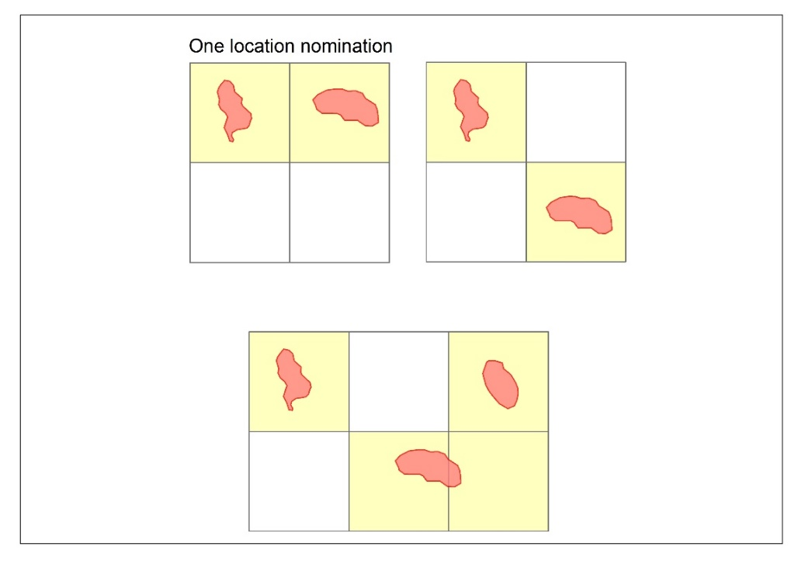
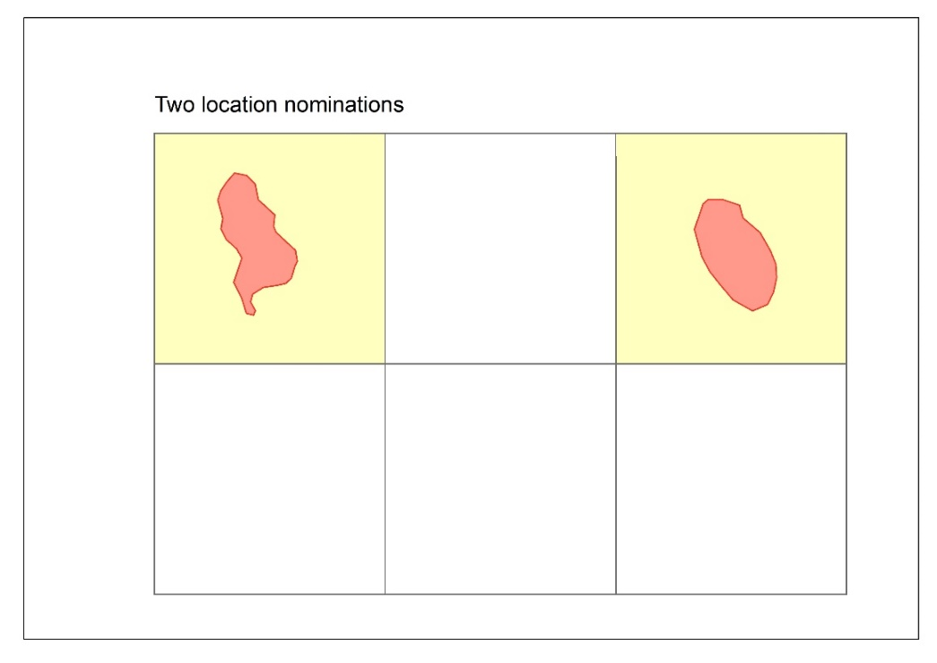
  - In forming its opinion, the Joint Authority may have regard to any other information, whether provided by the permittee or not.
  - The Joint Authority will only declare a location over a block or blocks that it is satisfied that the pool(s) extends into, generally based on a mid-case probability level of confidence.
  - The Joint Authority may decide that it is satisfied that the identified pool(s) extends to some, but not all, of the nominated blocks.
  - If the Joint Authority is not satisfied that a petroleum pool has been identified within any nominated block or blocks, the nomination of that/those particular block or blocks will not be accepted by the Joint Authority.
  - If the Joint Authority forms an opinion that the permittee is entitled to nominate the block or blocks, a declaration of a location is made in writing, and a copy of the declaration will be published in the Australian Government Gazette.

Application period
  - A declared location comes into force for a two year period on the date on which it is declared, during which time the permittee may apply for a retention lease or a production licence in relation to the declared location or to vary or revoke the location. This is referred to as the ‘application period’.
  - During the application period it is expected that the permittee will undertake an assessment of commercial potential of the petroleum accumulation to progress the location block or blocks towards either an application for a retention lease or production licence.
  - The OPGGS Act provides for the two year application period to be extended for up to a further two years. A written application for an extension must be made by the permittee within two years from the date on which the location is declared.
  - The request to extend the application period should be made at least 90 days before the end of the initial two year period.
  - As a matter of policy, requests for extension of the application period will usually only be granted where there are exceptional circumstances, or where force majeure grounds exist.
  - The request to extend the application period should include a schedule of activities that will be conducted during the extended two year application period to progress the location block or blocks towards either a retention lease or production licence and justification as to why these activities have not been able to be undertaken in this initial two year application period.
  - If an exploration permittee takes no action in relation to a block or blocks in a declared location before the expiration of the application period i.e. does not apply for a retention lease or production licence or has not applied for and received notice that the Joint Authority has revoked the declaration of location, the block or blocks will revert to vacant acreage and no longer form part of the exploration permit area.
  - NOPTA monitors the status of declared locations and provides reporting to the Joint Authority where exploration permittees have not taken action prior to the expiration of the application period

Timing

Nomination of blocks by permittee
  - The nomination of blocks for the declaration of a location does not extend the term of an exploration permit.
  - It is the permittee’s responsibility to maintain tenure of the underlying exploration permit and to ensure the nomination is lodged with sufficient time to facilitate a decision by the Joint Authority before the expiry of the exploration permit.

Joint Authority may require the permittee to nominate blocks
  - Under the OPGGS Act, the Joint Authority may require a permittee to nominate a block or blocks as a location if the Joint Authority forms the opinion that a permittee is entitled to nominate the block or blocks but the permittee has not done so.
  - If the Joint Authority requires a permittee to nominate a block or blocks as a location, the Joint Authority will issue a notice to the permittee (via NOPTA) giving 90 days to make the nomination. Permittees can apply for an extension of up to another 90 days to make the nomination.
  - If the permittee does not apply to declare a location over the identified block or blocks within the specified timeframe, the Joint Authority can nominate the blocks itself.

Variation of a declared location
  - A declared location may be varied to either add or remove a block, before the end of the ‘application period’, if the relevant criteria are met. For example, an application of this type may be made when new geoscientific information reveals that the petroleum pool(s) is within fewer blocks, or extends to an extra block, within the existing exploration permit.
  - A variation of a declared location can be made be at the permittee’s request or required by the Joint Authority.
  - A declared location can only be varied to add or remove a single block, per variation application submission. Separate applications (per block) are required to add or remove additional blocks.
  - A variation of a declared location does not extend the application period in which the permittee must apply for either a retention lease or production licence.
  - If a declared location has been varied so that it is over one less block, the block that has been removed remains part of the exploration permit and continues to be subject to the permit conditions.
  - Applications to vary a declared location should be made in writing at least six months before to the end of the application period.
Please refer to the application form on NOPTA’s website.
  - The assessment criteria used by the Joint Authority for a decision to vary a declared location require similar information to that required for an initial declaration of a location, and the application should include the information in section 3 of this guideline.

Revocation of a declared location
  - The permittee can request that the declared location be revoked before the end of the ‘application period’.
  - A revocation can only be made for the entire declared location. If a titleholder wishes to remove only a single block from the declared location, the titleholder should apply to vary the location.
  - The revocation of a declared location will result in the block or blocks remaining part of the exploration permit and continuing to be subject to the permit conditions.
  - A request to revoke a declared location should be made at least three months before the end of the ‘application period’. The permittee should include reasons for the request and demonstrate that there are sufficient grounds for the revocation.
Please refer to the application form on NOPTA’s website.
  - A request to revoke a location will not be approved if the purpose of the revocation is to reapply for the declaration of a location over the same accumulation.

Blocks no longer part of an exploration permit, retention lease or production licence
  - The Joint Authority must revoke a declared location if an exploration permit is no longer in force over a block or blocks that form part of the declared location.
  - This ensures that a block or blocks that have reverted to vacant acreage such as following expiry of a permit, do not remain covered by a location if a new exploration permit is awarded through an acreage release process.
  - A declared location will not be revoked on the grounds of expiration of the exploration permit while an application for a retention lease or production licence is under consideration by the Joint Authority.
  - If a permittee applies for a retention lease or production licence in respect of some or all of the blocks in a declared location, and the Joint Authority refuses to grant a retention lease or production licence over any of the blocks that were applied for, because it is not satisfied that:
    - the block or blocks contain petroleum or
    - recovery of petroleum from the block or blocks is likely to become commercially viable within 15 years
the Joint Authority must revoke a declared location in relation to the block or blocks that was/were refused. If the underlying exploration permit remains in force, the revoked declared location block or blocks remain part of the exploration permit and continue to be subject to the permit conditions. If the permittee wants to later apply for a production licence or reapply for a retention lease over the block or blocks, the permittee must re-nominate the block or blocks as a location before making the application.

Flowchart for declaring a location
In relation to an application by an exploration permit holder

Table of revisions
Date of commencement | Version no. | Purpose/changes made
December 2025 | 5 | - Re-formatted to new departmental template.  - Updates to reflect change of government policies and alignment with the Future Gas Strategy.
July 2022 | 4 | - Update to new department name.
February 2020 | 3 | - Update to new department name.
May 2019 | 2 | - Clarification on application process
July 2017 | 1 | - New guideline for the Declaration of Location

Should be provided in appropriate geo-referenced file formats in a ‘Spatial Data’ appendix.

