# Developing a GHG Resource – GHG Holding Lease Application

All fact sheets should be read in conjunction with the [*Offshore Petroleum and Greenhouse Gas Storage Act 2006*](http://www.comlaw.gov.au/Series/C2006A00014)(**the OPGGS Act**), associated regulations, relevant guidelines and policies (available on [NOPTA’s website](http://www.nopta.gov.au)).

This fact sheet provides information on the application and assessment processes for a greenhouse gas (**GHG**) holding lease or GHG cross-boundary holding lease (**GHG holding lease**) by:

* the holder of a GHG assessment permit or cross-boundary assessment permit (sections 324 or 329A of the OPGGS Act); or
* the holder of a GHG injection licence or cross-boundary injection licence (sections 330 or 335A of the OPGGS Act); or
* the holder of a petroleum retention lease (section 343 of the OPGGS Act)

where there is one or more declared identified GHG storage formations (**DoSF(s)**) wholly within the permit, lease or licence area and the applicant is not currently in a position to inject and permanently store a GHG substance but is likely to be able to do so within 15 years.

The application should set out the barriers to the injection and permanent storage of a GHG substance(s) into the DoSF(s).

**Note:** this fact sheet does not cover application and assessment processes for a special GHG holding lease by an unsuccessful applicant for a GHG injection licence or GHG cross‑boundary injection licence (see sections 336 or 342A of the OPGGS Act).

This fact sheet should be read in conjunction with the OPGGS Act, the *Offshore Petroleum and Greenhouse Gas Storage (Greenhouse Gas Injection and Storage) Regulations 2023* (the **GHG Regulations**) and the following [guidelines and fact sheets](https://www.nopta.gov.au/guidelines-and-factsheets/index.html):

* Guideline: Offshore greenhouse gas assessment permits – work-bid;
* Offshore Greenhouse Gas Guideline for Consolidated Work-bid and Cross-boundary Greenhouse Gas Assessment Permits;
* Offshore Greenhouse Gas Guideline for Declaration of Identified Greenhouse Gas Storage Formation (**DoSF Guideline**);
* Offshore Greenhouse Gas Guideline for Injection Licences (**Injection Licence Guideline**);
* Guideline: Retention Leases;
* Significant Risk of a Significant Adverse Impact (**SROSAI**) fact sheet (**SROSAI Fact Sheet**); and
* NOPTA Forms Guidance – Greenhouse Gas (**GHG Forms Guidance**).

## Further information on applications for GHG holding leases and related matters will be provided in a future Offshore Greenhouse Gas Guideline for Holding Leases.

## When can I apply?

Different application periods apply, as outlined below.

**Note:** the application must be validly submitted before the last application date. NOPTA recommends applying at least two weeks prior to the last application date to allow adequate time to determine if the application submission is valid (see also ‘Step 2 – GHG holding lease application’ below).

**Holder of a GHG assessment permit or cross‑boundary assessment permit:** The application period for the holder of a GHG assessment permit or cross-boundary assessment permit, with a single DoSF is 12 months after the day on which the DoSF was

declared.[1] If there are multiple DoSFs, the application period is 12 months after the earliest day on which a DoSF was declared (see subsections 324(8) and 329A(8) of the OPGGS Act and ‘Multiple DoSFs within a single relevant GHG title or petroleum retention lease’ below).

The application period may be extended for a period of no more than 180 days (see paragraphs 324(8)(b), 329A(8)(b) and subsections 324(9) and 329A(9) of the OPGGS Act). An ‘*Extension of application period for a greenhouse gas holding lease*’ application form and GHG Forms Guidance are available on [NOPTA’s website](http://www.nopta.gov.au)).

### Holder of a GHG injection licence or cross-boundary injection licence: The application period is 5 years from the day the licence was granted (see subsections 330(3) and 335A(3) of the OPGGS Act).

### Holder of a petroleum retention lease: An application for a GHG holding lease must be made while the petroleum retention lease is in force (see subsection 343(1) of the OPGGS Act).[2]

## What is the application and assessment process?

### Step 1 – engage with NOPTA

Before a titleholder who holds a title with one or more DoSFs wholly situated in the title area submits an application for a GHG holding lease, we recommend that the titleholder engage with NOPTA, initially via [ghg@nopta.gov.au](mailto:ghg@nopta.gov.au) to discuss the approvals process, and the information to be included in an application (see below).

### Step 2 – GHG holding lease application

**Valid Submission:** For an application to be validly submitted, it must be:

* made in the approved manner (section 426 of the OPGGS Act) and be in the approved form (paragraphs 324(7)(a), 329A(7)(a), 330(2)(a), 335A(2)(a) and 343(2)(a) of the OPGGS Act);
* accompanied by any information or documents required by the form (paragraphs 324(7)(b), 329A(7)(b), 330(2)(b), 335A(2)(b) and 343(2)(b) of the OPGGS Act); and
* accompanied by the applicable application fee (section 427 of the OPGGS Act).

For further information, an application form and the GHG Forms Guidance are available on [NOPTA’s website](http://www.nopta.gov.au).

**Multiple DoSFs within a single relevant GHG title or petroleum retention lease:** Where there are multiple DoSFs, an application for a single GHG holding lease can made if the DoSFs:

* extend only to one block and a vertical line would not pass through a common point.[3]
* extend to one or more blocks and a vertical line would pass through a common point.[4]and
* extend to more than one block and a vertical line would not pass through a common point if at least one of the blocks provided are adjoining (touching) or have a point in common. [5]

In all other cases, separate GHG holding lease applications will be required for each DoSF. The above scenarios are illustrated in Attachment 1 – Multiple storage formations.

**Supporting information – GHG holding lease application**

The application should put forward a program of work to address the barriers to injection and permanent storage of a GHG substance(s), which may include:

* details of steps or actions that are likely to allow the applicant to inject and permanently store a GHG substance(s) in the identified formation within 15 years with indicative timeframes. For example:
  + technical appraisals (including appraisal of well remediation or re-use of infrastructure);
  + technological developments;
  + market conditions;
  + any agreements reached with potentially affected petroleum titleholders (see SROSAI Fact Sheet);
  + access to third party infrastructure; and
* supporting evidence that the proposed steps or actions are sufficient to enable the project to proceed. For example, the internally accepted economic criteria used by the applicant to assess viability; and
* any other information the applicant wishes to be considered in the application.

Assumptions that impact on the ability of the project to proceed should be clearly identified. For example:

* uncertainty ranges associated with development costs due to immature technical understanding; or
* dependence on access to third-party infrastructure or sources of GHG substance(s); or
* where the estimated internal rate of return (**IRR**) is sufficient for the project to proceed under current market conditions, the applicant should provide evidence that there are other factors preventing the project proceeding (e.g. market issues or technical risks).

Information such as contract availability, access to markets, existing infrastructure, and subsurface considerations may be assessed by NOPTA using information provided in the application, obtained through a request for further information, or sourced independently.

Critical path activities should be discussed and supported by a project schedule that aligns with the project being able to inject and permanently store a GHG substance within 15 years and the proposed work program for the 5 year holding lease term (see ‘Proposed Work Program’ below).

**Existing knowledge of the storage formation**: Applications should demonstrate existing knowledge of the DoSF(s), including the fundamental suitability determinants (see subsection 21(8) of the OPGGS Act).

If the knowledge of the storage formation(s) has significantly changed since the DoSF, particularly relating to the fundamental suitability determinants and/or the spatial extent, updated information should be provided, and will potentially require a variation to the DoSF (see DoSF Guidelines).

**Development Concepts:** The application should adequately consider all reasonable development concepts. Each concept should be supported by a detailed assessment and discussion, including schematics, indicative timeframes, advantages and disadvantages and a comparison between the identified concepts.

If a preferred development concept has been identified, include information as to the basis for selecting that option, along with discussion on the limitations of other concepts considered. Please reference previous applications where appropriate.

Where appropriate, provide information on the infrastructure components for each concept. For multiple DoSFs, please provide separate information for each DoSF and clearly identify any shared facilities. Include cost estimates in real units, specifying the currency and cost estimate class. These should provide support for the cost estimates in the project cash flows. Annual operating costs should also be provided, along with the basis for the assumptions.

Where a development concept considers re-use of infrastructure, provide information on its suitability, and current operational status. This should also include potential future work needed to demonstrate that the infrastructure is suitable, including any proposed remediation. Applications should provide evidence of any preliminary negotiations with infrastructure owners and current understanding of likely access costs.

**Component of a larger project**: Where the applicant refers to integration in a larger project as a development option, provide comprehensive supporting information on the project as a whole. This may include details of other storage formations and/or petroleum fields which utilise project facilities, or those intended to be developed through the same facilities, and the anticipated development path for the project including timeframes.

**Commercial route-to-market:** The application should contain supporting information, including market access, prices and timing of potential market opportunities, with refences to information sources.

Where the project is dependent on securing source(s) of GHG substances, the application should provide evidence of efforts made to obtain contracts, including any information on approaches by third parties, engagement with potential sources of GHG substances and reasons for not proceeding.

**Note:** NOPTA’s assessment may adopt its own price forecast.

**Proposed Work Program**: Work programs are unique to each GHG holding lease. Where multiple DoSFs are involved, a standalone work program should be provided for each DoSF, detailing the relevant activities and indicative expenditures specific to each formation. The proposed work program should clearly identify which activities and expenditures relate to each DoSFs, as well as any activities or expenditure that are generic across the proposed lease. Please refer to the approved form and GHG Forms Guidance available on [NOPTA’s website](http://www.nopta.gov.au).

The application should include a detailed discussion of how the work program addresses the primary constraints to the development of the DoSF(s) and to the viability of injecting and permanently storing a GHG substance(s) in the storage formation. It should also identify key decision points inclusive of indicative timing and expenditure.

The work program should also address areas where information on which to base project decisions is currently insufficient. For example, further seismic definition, appraisal drilling, environmental studies or other technical activities may be appropriate to better define the storage resource or matters relating to the fundamental suitability determinants such as the composition of the proposed GHG substance(s) or engineering enhancements. The work program should set out each activity to be undertaken as a separate item, including clear descriptions of the work to be undertaken where engineering, environmental or marketing studies are proposed. If applicable, commercial activities to secure sources of GHG substances should also be included.

Applications should also identify the phasing of activities. While a year-by-year breakdown is generally not required for the five-year GHG holding lease term, the work program should be consistent with what a titleholder could reasonably be expected to undertake to support timely project progression.

Proposed work program activities under a GHG holding lease should include (where applicable):

* project feasibility studies to bring the project closer to Front-End Engineering Design (FEED) and Final Investment Decision (FID);
* commercial negotiations with operators of third-party infrastructure, or regarding access to potential sources of GHG substance(s), including compositional evaluation;
* review of exploration data or proposals to undertake further appraisal or exploration activities to improve understanding of the storage formation(s);
* evaluation of legacy well barriers and development of remediation plans;
* evaluation of existing petroleum infrastructure proposed to be re-used for GHG injection and storage activities (if any);
* acquisition of baseline monitoring data;
* review of new and emerging technologies to assess viability of other potential development concepts, monitoring activities or opportunities for reductions in capital costs; or
* development of a draft site plan.

**Project economics:** The economic basis of the project will be assessed by NOPTA with reference to:

* each viable development option (including any phased development);
* carbon storage resource estimates in accordance with the Society of Petroleum Engineers Storage Resource Management System contingent storage resources levels (1C/P90, 2C/P50 and 3C/P10), and any critical uncertainties relating to these estimates; and
* the current fundamental suitability determinants within the DoSF.

Cash flows for each viable development option should be provided based on storage resource estimates as defined by the fundamental suitability determinants and current P50 estimates of capital expenditure (and cost class).

Where an applicant’s internal economic assessment criteria rely on scenarios based on other levels of storage resource estimates, less than those defined by the fundamental suitability determinates, and/or a range of carbon price forecasts, cash flows for these scenarios should also be provided stating the uncertainties, sensitivity assumptions and capital cost class estimates. Minimum economic thresholds used by an applicant to determine commercial viability should be clearly set out.

**Note:** NOPTA will analyse the extent to which there are reasonable grounds for adopting any alternative assumptions and methodologies. Applications should provide detailed supporting information in order to satisfy the criteria in sections 325, 329B, 331, 335B and 344 of the OPGGS Act (as applicable).

### Step 3 – Assessment

Once all relevant information has been provided by the applicant, NOPTA, in consultation with the National Offshore Petroleum Safety and Environmental Management Authority (**NOPSEMA**) (as applicable), will assess the application against the relevant criteria and provide advice to the RCM (or Cross-Boundary Authority (**CBA**) if applicable) for decision.

For all holding lease applications, the assessment will be made in respect of the matters set out in sections 325, 329B, 331, 335B, or 344 of the OPGGS Act (as applicable), and include:

* whether the applicant is not, at the time of application, in a position to inject and permanently store a GHG substance into the DoSF concerned (or at least one of the DoSFs concerned in the case of multiple DoSFs), but is likely to be within 15 years; and
* whether the proposed work program sufficiently reduces the barriers to project viability; and
* whether the technical and financial resources available to the applicant are sufficient to carry out the works, authorised by the lease and discharge the obligations imposed under the OPGGS Act in relation to the lease.[6]

Please see [NOPTA’s website](http://www.nopta.gov.au) and the GHG Forms Guidance for further information in relation to applicant suitability, declaration of experience and disclosures, financial resources, and how to execute NOPTA forms and instruments.

We would recommend allowing up to three months for a GHG holding lease to be assessed by NOPTA. This is an indicative estimate, contingent on any subsequent requests for further information.

**Note:** the assessment process for a GHG holding lease does not evaluate the suitability of the development concepts presented (including those involving re-use of infrastructure), beyond the information required to demonstrate that the applicant is not currently able to inject and permanently store a GHG substance but is likely to be able to do so within 15 years. The detailed evaluation of development concepts is undertaken through separate regulatory submissions and processes managed by both NOPTA and NOPSEMA.

### Step 4 – Offer, acceptance and grant

Where an application is made pursuant to sections 324, 329A, 330, 335A or 343 of the OPGGS Act, and the RCM or CBA (as applicable) is satisfied of the matters outlined in sections 325, 329B, 331, 335B and 344 of the OPGGS Act, the RCM or CBA (as applicable) must give to the applicant an offer document stating that the RCM or CBA is prepared to grant a GHG holding lease over the block(s) specified in the application.[7]

To accept the offer, the applicant must:

* by written notice request the grant of the lease under section 431 or 431A of the OPGGS Act within the applicable timeframe. This period is 30 days, unless a longer period not exceeding 60 days has been requested and approved by the RCM; and
* lodge with the RCM a security in the form and amount specified in the offer document (if any) within the same timeframe applicable to accept the offer.

If the applicant makes a request for the grant of the GHG holding lease and has lodged the specified security with the RCM (if any) in the applicable timeframe (see section 433 of the OPGGS Act), the RCM or CBA, as applicable, must grant a GHG holding lease to the applicant over the block or blocks specified in the offer document (see sections 327, 329D, 333, 335D and 345 of the OPGGS Act).

## Variation of the application

Pursuant to subsections 324(10-15), 329A(10-15), 330(4-9), 335A(4-9) or 343(3-8) of the OPGGS Act, an applicant may, at any time before an offer document (or a notice of refusal) is given in relation to the GHG holding lease application, vary its application for a GHG holding lease. A variation may be made:

* on the applicant’s own initiative; or
* at the request of the RCM or CBA (as applicable).

The variation must be made in the approved manner and may set out any additional matters that the applicant wishes to be considered.[8] Please refer to information on approved manner, available on [NOPTA’s website](http://www.nopta.gov.au).

**Renewal of a Holding Lease**

Pursuant to section 347 or 350A of the OPGGS Act, a GHG holding lease can be renewed once for a term of 5 years.

The renewal must be made in the approved form and approved manner and may set out any additional matters that the applicant wishes to be considered.

## More information?

If you have any specific questions, please contact NOPTA via [ghg@nopta.gov.au](mailto:ghg@nopta.gov.au).

***Please note:*** *this document is intended as a guide only. It is subject to, and does not replace or amend the requirements of, the Offshore Petroleum and Greenhouse Gas Storage Act 2006 and associated regulations, which should be read in conjunction with this fact sheet. It should not be relied on as legal advice or regarded as a substitute for legal advice in individual cases.*

## Version history

|  |  |  |
| --- | --- | --- |
| Version | Date | Comment |
| 1.0 | 07/10/2025 | New GHG fact sheet |
|  |  |  |

# Attachment 1 – Multiple storage formations

The following diagrams provide a schematic interpretation of the scenarios in section 324 of the OPGGS Act. The top diagram in each pair is a cross sectional view, and the lower diagram is a plan view.

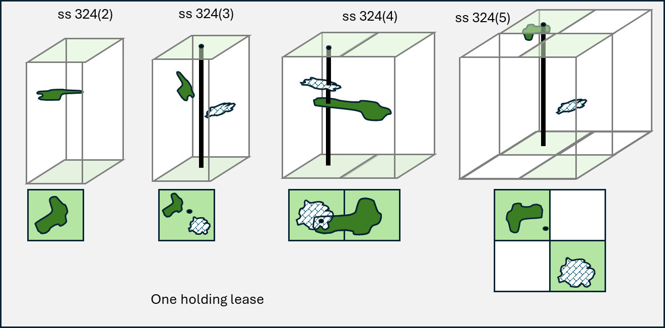

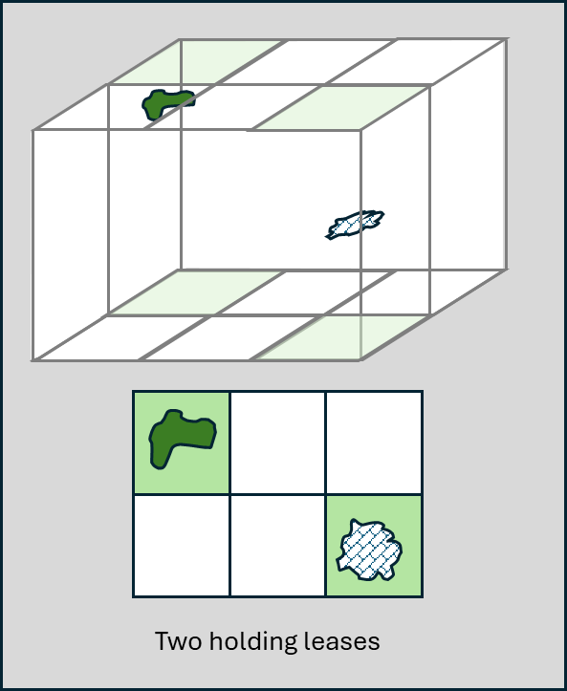

1. Subsection 313(8) OPGGS Act provides that if a declaration in force has been varied, a reference to the declaration is a reference to the declaration as varied. This may impact how the application date is calculated for multiple DoSFs.
2. For tied titles, see section 13 of the OPGGS Act and ‘Additional considerations for petroleum titleholders’ in the Greenhouse Gas Injection Licence Guideline (section 3.13 at p10)
3. GHG holding lease (other than a cross boundary GHG holding lease) - paragraphs 324(3)(a) & (b); Cross boundary GHG holding lease - subsection 329A(3); Petroleum Retention Licence - subsection 343(1B);
4. GHG holding lease (other than a cross boundary GHG holding lease): (paragraphs 324(4)(a) & (b); Cross Boundary GHG holding lease: subsection 329A(4); Petroleum Retention Licence - subsection 343(1C).
5. GHG holding lease (other than a cross boundary GHG holding lease) - paragraphs 324(5)(a), (b) & (c); Cross Boundary GHG holding lease - subsection 329A(5); Petroleum Retention Licence - subsection 343(1D).
6. Paragraph 325(1)(c) OPGGS Act.
7. The RCM and the CBA (as applicable) may grant a GHG holding lease subject to whatever conditions are considered appropriate (subsections 320(1) and 320A(1) of the OPGGS Act). The conditions of a GHG holding lease, renewal and variation are outside the scope of this fact sheet and will be covered under a future GHG holding lease guideline or fact sheet as required.
8. Pursuantto sections 329, 329F, 335, 335F and 346 of the OPPGS Act, if a transfer of a GHG assessment permit, cross-boundary assessment permit, injection licence, cross-boundary assessment permit, injection licence, cross-boundary injection licences or petroleum retention lease has been registered under section 530 of the OPGGS Act after an application for a holding lease is made and before the RCM has made a decision to either offer or refuse to grant a holding lease, the transferee will be treated as the applicant for the holding lease.